**Road to the Rave**

**Sustainable Transportation Plan for**

**Volgas Tours to Complex Festival**

**June, 2025**

**Executive Summary**

This Sustainable Transportation Plan has been developed for Complex Festival, a two-day (hard) techno event held on July 27th and 28th in Het Geusseltpark located in Maastricht. This event is attracting approximately 15,000 visitors per day. Due to the events regional attractiveness and limited public transportation at night many attendees travel to the event by car. This comes with environmental and safety concerns, since most attendees drink alcohol or consume drugs at the event.

To deal with these challenges this plan focusses on three areas: a collaboration with Volgas Tours a transportation company in Zuid-Limburg. They will perhaps provide a organised bus service. Besides the bus service there is a promotion campaign for inspiration and a pre event survey conducted to get insights into attendees transportation habits. The survey was shared on social media channels associated with Volgas tours to target past and potential festival attendees.

The goal of this initiative is to reduce the number of vehicles, minimize emission and mostly ensure safe travel for attendees.

This approach supports professional learning objectives like ethical responses to systemic challenges in the event industry such as sustainability and public safety.

**Objectives**

Main Goal: Reduce individual car use and promote sustainable and safe travel to complex festival.

Sub-goals:

Partner with a transportation company

Promote through targeted campaigns

Conduct a pre-event transportation habits survey

Ensure accessibility and inclusiveness in travel options

**Volgas tours**

‘’ Hi I am Glenn, I love parties and festivals. When I went to an event with my friends, I liked to arrange a bus for it so that we could go with a large group. This friend service has grown into a start-up company in mid-2023: VolGas Tours

Unfortunately, the big parties from our beautiful Limburg are often difficult to reach. My goal is to relieve as many partygoers from the south as possible of the worry about transportation to a party or festival. VolGas Tours uses luxury coaches for this. So whether you are sitting or standing dancing in the bus, I make sure that you are always brought safely and comfortably to the party and back home’’ (Volgas tours, n.d.)

This aligned with my own personal experiences and values. Therefore I reached out to Glenn to be able to collaborate on something he has not done before – organising a bus to complex festival. I noticed my friends and me struggling to get home after the festival even tough it is so close to home. Due to no one being able to safely drive home after the festival and taxi’s being quite expensive I thought this could be the better alternative and did research to show Glenn how this can help our society by providing responsible travel and being a better environmental choice.

**Research**

Bus transportation is more ethically responsible compared to individual car use, since it has lower emissions per passenger. According to milieu centraal a diesel car emits 2.64 kilograms of co2 per liter of fuel. For a petrol car this is 2.39 kilograms per liter (Milieu centraal, n.d.). The average emission per bus passenger is around 933 grams (Elk Antwoord, n.d.). This means that per person traveling by bus is creating less emission especially when they are completely filled. Encouraging group travel through organized bus transportation reduces the number of vehicles on the road and contributes to lower emission and therefore a better environment.

According to (Eco-Reizen, n.d.) ‘’touringcars are the cleanest motor vehicles when measured per passenger-kilometer’’. Buses spread their emissions over many different people. Besides this, touringcar companies mostly invest in newer, environmentally cleaner vehicles which help further to reduced emissions. Therefore for events and group travels buses are a more sustainable option. Another issue found in the survey analysis is driving under influence. Using drugs and driving is illegal and affects your own safety and those of others. Drugs have an impact on your perception, reaction time and coordination. How long drugs stay active in your blood differs per person depending on height, weight etc. weed is not affective anymore after 8+ hours, XTC for 16 – 58 hours, speed 10 – 40 hours and cocaine after 4+ hours (Drugsuitgaan.nl, n.d.). traces can still be detectable after effects wear off increasing risk during police checks. Planning a safe way home such as using public transport or organised transport is suggested to prevent license suspensions, fines and increase safety of event attendees and other road users.

Here is an overview from NOS, 2017 with how long drugs take to get out of your system

* **MDMA (ecstasy)**: After taking one pill (approximately 171 mg), it can take at least 16 hours—and in some cases up to 40 hours—for the MDMA levels in your blood to drop below the legal limit of 50 micrograms per liter. If multiple pills are taken, the duration extends further.
* **Speed (amphetamine)**: Depending on purity and dosage, it may take between 10 to 20 hours for levels to decrease below the legal threshold. Repeated use can prolong this period to 26–37 hours.
* **Cannabis**: THC levels can peak quickly after use, and while they decrease over time, it's generally advised to wait at least 6 to 8 hours before driving.
* **Cocaine**: Typically, it takes about 4 hours for cocaine levels to diminish to permissible levels, but heavy or repeated use can extend this timeframe.
* **GHB**: After consuming a standard dose, it may take approximately 8 hours for levels to fall below the legal limit. Multiple doses can significantly increase this duration. (NOS, 2017.)

**Cases**

Harmony of Hardcore

After the Harmony of Hardcore festival the police did drug controls. 80+ people had to do a test oh which 21 tested positive. They all had to get blood tests to be able to identify which drugs had been used. Drivers who had more than 50 micrograms of cocaine or over 3 micrograms of THC per liter of blood can be prosecuted with fines, driving bans or going to prison. Most insurance companies also don’t cover costs if the driver was under influence if anything were to happen. (RTL nieuws, 2023)

Rij Drugsvrij

In Brabant there is concern over driving under the influence after events. Youth organization TeamAlert highlights that ‘’more young individuals are consuming substances like ecstasy at festivals and subsequently choosing to drive, posing significant risks to road safety. ‘’ (TeamAlert, n.d.). after the harmony of hardcore occurrence there was a big concern of young people overestimating their driving skills. There is a campaign launched called “Rij Drugsvrij’’ (drive drugs – free). It is created to raise awareness and promote sober driving or other transportation methods after events

Ground Zero Festival

At the Ground zero Festival seven drivers have been arrested for driving under the influence. Five were suspected of driving under influence and got tested. The police administered 2,100 breathalyzer tests at the festival. Annually 80 fatalities happen in traffic due to driving with drugs. ‘’The risk of an accident is three times higher after using soft drugs, four times higher with cocaine, and ten times higher when combining multiple substances.’’ (AD.nl, 2012.)

Increase in Traffic Fatalities

According to date from the Dutch police, 13 people died in 2016 from driving under influence, whereas in 2022, the number increased to 61. The actual figures are probably higher, due to investigations typically conducted only when the driver survives the accident.

‘’In 2022, approximately 43,000 individuals were fined for driving under the influence in the Netherlands. Of these, around 25,000 had consumed excessive alcohol, and 18,000 were under the influence of drugs, particularly cannabis. ‘’ (NOS, 2023.)

**Pre-Event Survey**

Appendix A

This questionnaire received a total of 54 responses from people who are going to or have been to Complex festival. This was sent out to get a better understanding of the transportation habits of the festival-goers and get an insight into the interest rate for a organised bus travel.

A survey was used because people can answer it whenever they have, they can stay anonymous when talking about drug use and it is an easy way to share the link and receive as many responses as possible. The survey was sent end shared on social media platforms by me and Volgas tours. Specifically in the WhatsApp group community of people who live in the area.

The majority of visitors travel as passengers in the car (51.9%), followed by public transport with (22.2%), (18.5%) of the visitors travel by car as driver, these are 10 of the 54 visitors. The other 7.5% go on foot or by bike/scooter.

37 people indicate that they make a choice because this is the fastest option from A to B. 13 people choose this because it is the cheapest option and 12 because the public transport timetable does not fit in well. 8 people indicate that there is no alternative available for them.

18 of the 54 people travel from Heerlen to Complex Festival, 8 people from Brunssum and 4 from Maastricht. The remaining 24 people come from surrounding areas such as Kerkrade, Landgraaf, Valkenburg, Beek, Geleen, Hoensbroek and Sittard.

 (46.3%) indicate that they will use both alcohol and drugs during the event, (22.2%) only drugs, (20.4%) consumption of alcohol and (11.1%) will remain sober during the event.

When asked ''Did you drive home under the influence after the festival or are you going to do so? (e.g. car, scooter, motorcycle)'' (79.6%) indicate that they will not do so, the other (20.4) will drive home themselves.

It is remarkable that 10 people are car drivers and 2 people are bike or scooter drivers. 11 people indicate that they will drive back under the influence.

(38.9%) would be interested in an organized bus trip to Complex festival. 5 out of 54 people find sustainability important in their choice of transport, 23 people do not find this important at all, the rest are in between.

**Experiences with traveling from Zuid-Limburg to an event**

‘’I don’t like traveling with public transport. Most of the times it takes you longer to get to your location and you are stuck to specific times. Events and festivals are usually till quite late and there are no trains or busses going anymore”

– Celine (Kerkrade, Zuid-Limburg)

‘’Because I find it really hard to get back home to Limburg with public transport I sometimes cancel events or decide not to go even though I really wanted to. If I do go I usually have to leave early to get the last train back to Limburg, that makes me quite sad because I miss things.’’

– Tio (Heerlerheide, Zuid-Limburg)

‘’Going to events in Utrecht, Nijmegen or Amsterdam is always a big drama. Public transport from Heerlen is never organised well and we always have to take multiple trains. It is also quite tiring to have to travel for these long hours.’’

– Megan (Heerlen, Zuid-Limburg)

‘’I almost always go to Sportpaleis in Antwerpen. This venue is easily reachable by car and my concerts are always amazing. It is only chaotic at the entrances. Public transport is okay for me but if I take it I have to leave earlier since its still 2+ hours to get back usually.’’

- Laura (Brunssum, Zuid-Limburg)

‘’When you go with your friends to an event it’s fun. When you go with public transportation it can be expensive, but if you get a group travel ticket you can share the costs of the ticket. Also you can socialise with more people and make more friends. It can take long with public transportation but to kill time you can play some games, talk, etc.’’

-Alyssa (Kerkrade, Zuid-Limburg)

‘’As someone who sometimes works at events and really enjoys going I find it aanoying that they are mostly so far away, I usually go with a big group of friends and everyone drives sometimes or we take an organised bus travel.’’

-Kyan (Heerlen, Zuid-Limburg)

**Conclusion**

Research shows that bus transport is a better environmentally and ethically responsible choice for large scale events instead of individual car use. A diesel car emits approximately 2,64 kg of co2 per litre of fuel, for a petrol car this is around 2.39 kg (Milieu Centraal, n.d.). Compared the average co2 emission is approximately 933 grams per bus passenger (Elk antwoord, n.d.). in addition buses often use newer vehicles and emission is spread over multiple people, therefore reducing the environmental impact per person (Exo-Reizen, n.d.).

Besides environmental concerns the research shows safety and legal risks that come with driving under the influence of drugs or alcohol. Drugs like MDMA, speed, cannabis and cocaine remain in bloodstreams for longer than the effects are active. This gives attendees a big risk during police checks and their driving ability. (Drugs en Uitgaan, n.d. & NOS, 2017)

Incidents like those at Gound Zero and Harmony of Hardcore came with many arrests and riving bans due to driving under the influence of substances (RTL Nieuws, 2023 & AD.nl, 2012) Traffic fatalities that involved substance use have risen from 13 in 2016 to 61 in 2022 according to NOS (2023).

The pre-event survey was filled out by 54 participants who are going to complex festival or have attended previous editions. Answers revealed a significant number of attendees are travelling by car as a passenger or driver. The concern shows when 20,4% admit they will drive back home after the event under influence. 38,9% of attendees would be interested in an organised bus travel tough they do not have an interest in sustainability. Complications such as poor connections with public transport were mentioned. Quotes from residents of Zuid-Limburg support this annoyance mentioning inconvenience of regular public transport and the benefits of group travel.

These findings align with the main goal: to reduce single-occupancy car use and promote sustainable travel. Collaborating with Volgas tours aligns with sub goals such as providing inclusive transport and promoting safe transport.

With this plan a collaboration between Volgas tours and Complex Festival can serve as a model for integrating sustainability and social accountability into the event as an important part of the social responsibility and community feeling.

**Promotion Campaign**

Other examples in Appendix B

*\*The promotion can be done in any way wanted or preferred, these examples are more campaign based on the socially responsible part\**

Afbeelding met tekst, voertuig, Landvoertuig, handschrift

Door AI gegenereerde inhoud is mogelijk onjuist.

**Evaluation & Implementation**

How can the success be measured?:

* If more than 20% of attendees use shared transportation methods in the first year
* Survey comparison of attendees driving home under influence
* Feedback surveys after the event

A possible collaboration between Volgas tours and Complex festival can generate income and brand awareness for volgas tours while it puts complex festival in a positive light for being ethically responsible and seeking greener and safer solutions in events by knowing their target audiences behaviour.

**Reference list**

AD.nl. (2012, September 2). *38 mensen met drugs opgepakt bij festival Ground Zero*. Retrieved June 1, 2025, from [https://www.ad.nl/binnenland/38-mensen-met-drugs-opgepakt- bij-festival-ground-zero~a6bab621/](https://www.ad.nl/binnenland/38-mensen-met-drugs-opgepakt-%09bij-festival-ground-zero~a6bab621/)

Complex Festival. (n.d.). *Neighbourhood*. Retrieved May 12, 2025, from <https://complexfestival.com/neighbourhood>

Drugsenuitgaan.nl. (n.d.). *Hoe lang na het gebruiken van drugs mag je weer deelnemen aan het verkeer?* Retrieved May 17, 2025, from [https://www.drugsenuitgaan.nl/vraag/hoe-lang-na-het-gebruiken-van-drugs- mag-je-weer-deelnemen-aan-het-verkeer](https://www.drugsenuitgaan.nl/vraag/hoe-lang-na-het-gebruiken-van-drugs-%09mag-je-weer-deelnemen-aan-het-verkeer)

Drugsenuitgaan.nl. (n.d.). *Verkeer*. Retrieved May 17, 2025, from <https://www.drugsenuitgaan.nl/veilig-uit-thuis/verkeer>

Eco-Reizen. (n.d.). *Achtergrondinformatie vervoer*. Retrieved May 21, 2025, from <https://www.eco-reizen.nl/achtergrond/vervoer/>

Elk Antwoord. (n.d.). *Hoeveel CO2 stoot een bus uit per jaar?* Retrieved May 12, 2025, from <https://elkantwoord.com/hoeveel-co2-stoot-een-bus-uit-per-jaar/>

Hanegraaf, M. (2023, July 20). *Festivalbezoekers vaker met drugs op achter het stuur: 'Zorgwekkend'*. Omroep Brabant. Retrieved May 21, 2025, from [https://www.omroepbrabant.nl/nieuws/4313434/festivalbezoekers-vaker-met- drugs-op-achter-het-stuur-zorgwekkend](https://www.omroepbrabant.nl/nieuws/4313434/festivalbezoekers-vaker-met-%09drugs-op-achter-het-stuur-zorgwekkend)[Omroep Brabant+1Drugs en Uitgaan+1](https://www.omroepbrabant.nl/nieuws/4313434/festivalbezoekers-vaker-met-drugs-op-achter-het-stuur-zorgwekkend?utm_source=chatgpt.com" \t "_blank)

Milieu Centraal. (n.d.). *Wat is de CO2-uitstoot van mijn auto?* Retrieved May 17, 2025 from [https://luchtkwaliteitsmeterwinkel.nl/wat-is-de-co2-uitstoot-van-mijn- auto/](https://luchtkwaliteitsmeterwinkel.nl/wat-is-de-co2-uitstoot-van-mijn-%09auto/)

NOS. (2017, July 1). *Zo lang mag je niet autorijden na drugsgebruik*. Retrieved May 17, 2025, from [https://nos.nl/op3/artikel/2180870-zo-lang-mag-je-niet-autorijden- na-drugsgebruik](https://nos.nl/op3/artikel/2180870-zo-lang-mag-je-niet-autorijden-%09na-drugsgebruik)

NOS. (2023, April 17). *Aantal doden door drugs en drank in het verkeer fors toegenomen*. Retrieved June 1, 2025, from [https://nos.nl/artikel/2471787-aantal-doden-door- drugs-en-drank-in-het-verkeer-fors-toegenomen](https://nos.nl/artikel/2471787-aantal-doden-door-%09drugs-en-drank-in-het-verkeer-fors-toegenomen)

RTL Nieuws. (2023, May 28). *Controle na festival: 21 automobilisten onder invloed van drugs*. Retrieved June 1, 2025, from [https://www.rtl.nl/rtl- nieuws/artikel/5387107/controle-drugs-auto-festival-haromony-hardcore](https://www.rtl.nl/rtl-%09nieuws/artikel/5387107/controle-drugs-auto-festival-haromony-hardcore)

**Appendix**

Appendix A

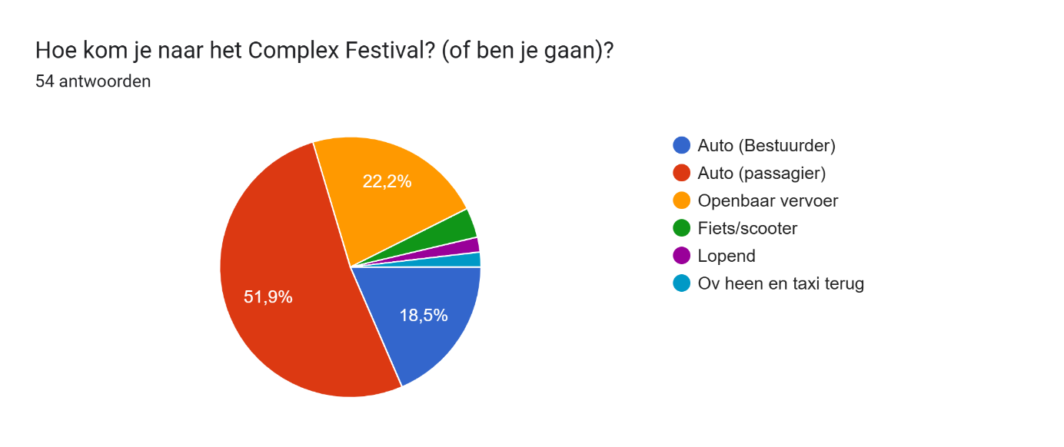

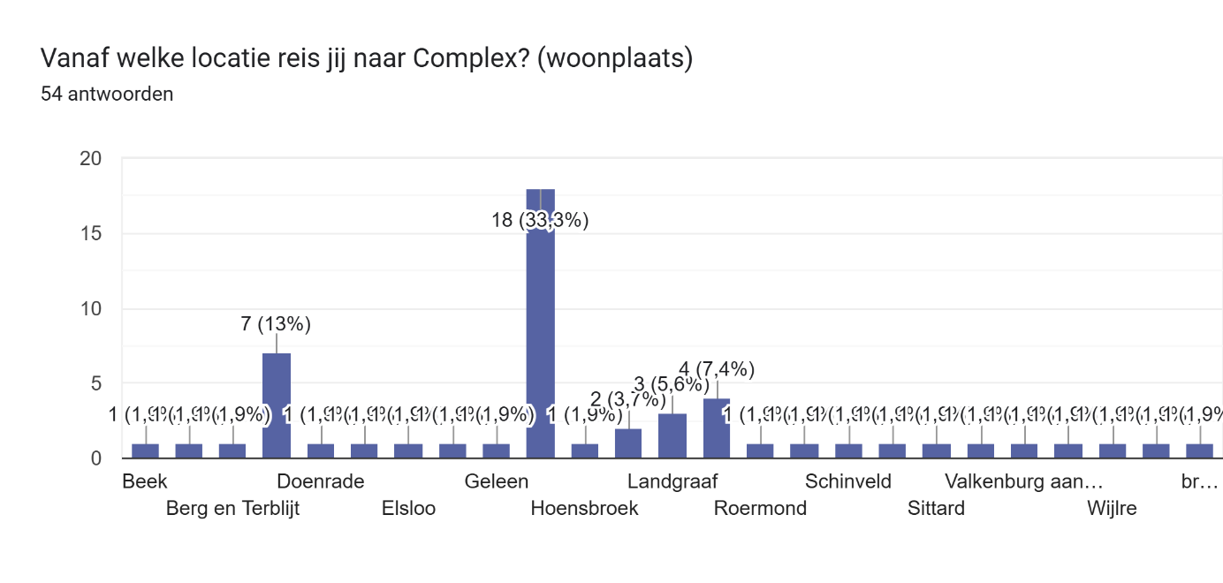 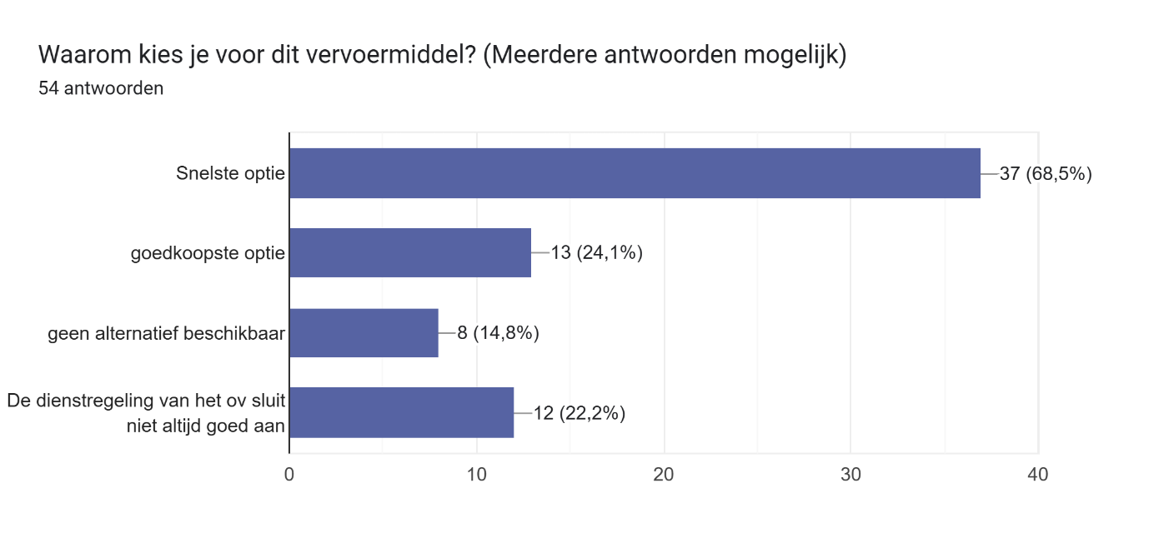

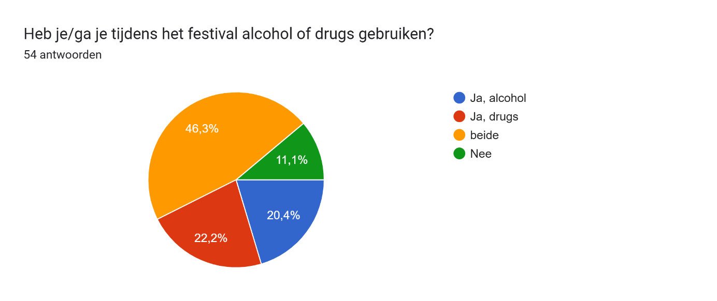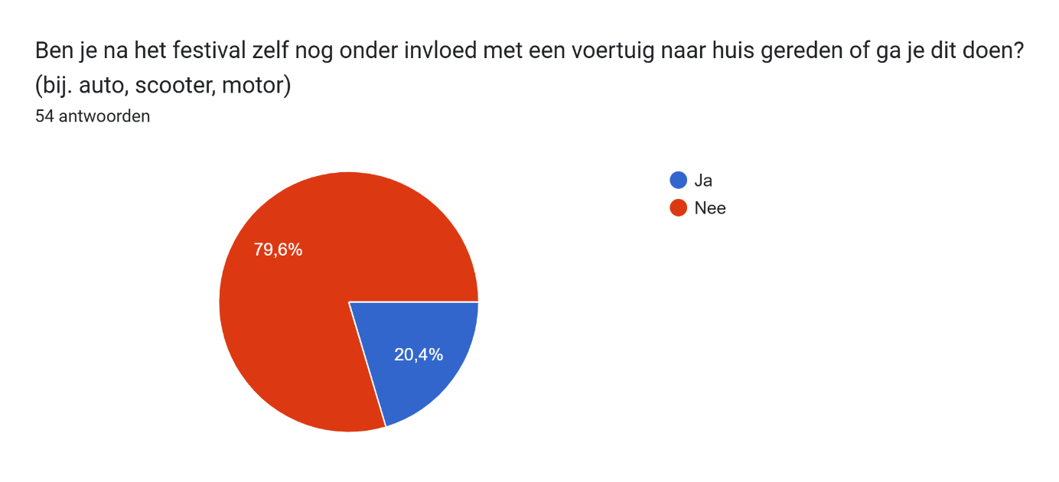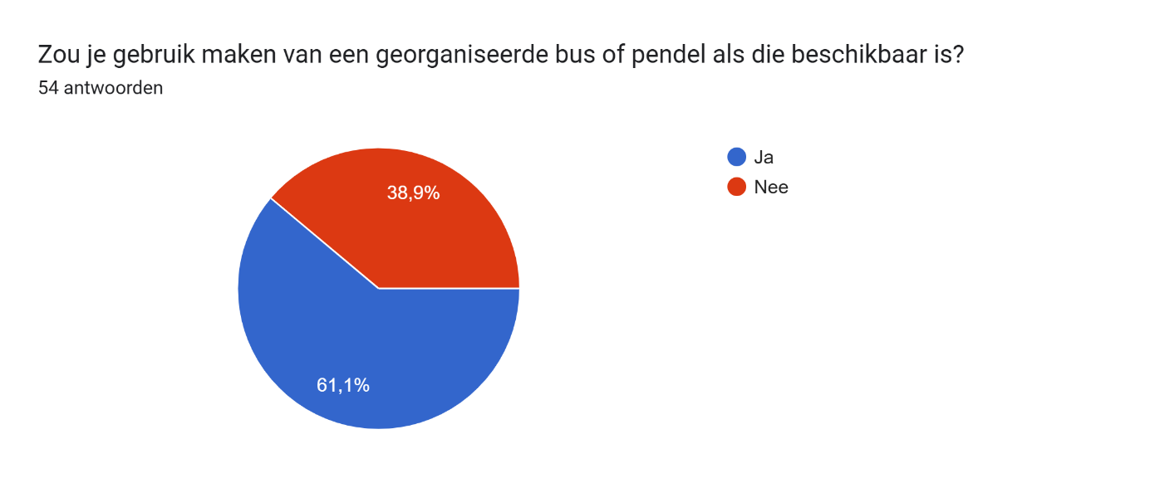 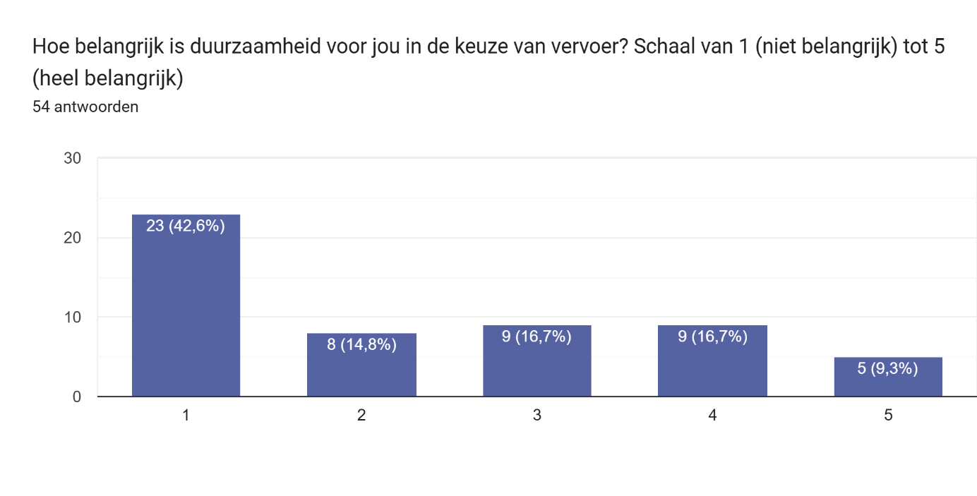

Appendix B

**Afbeelding met tekst, Frisdrank, groen, fles

Door AI gegenereerde inhoud is mogelijk onjuist.**Afbeelding met Graphics, violet, grafische vormgeving, Magenta

Door AI gegenereerde inhoud is mogelijk onjuist.