**Event preferences**

**Nina Vigliaroni**

**June 2025**

**Introduction**

I have a big passion for events and want to become an event manager/producer in the future. Therefore I find it in important to understand end be up to date on what people want. I want to understand what it is exactly that makes an event exceptional and unforgettable. I want to work in Limburg in the future a province that I personally believe lacks in the event sector and can be much bigger! As I aspire to create events in Limburg it is helpful to understand the preferences and expectations of people.

Understanding what people value in an event from A-Z can give the basic foundation for creating amazing experiences. By focusing on event preferences with a focus on Limburg I want to make sure I understand what the people want and need so I can play into this when organising an event.

**Research question**

RQ: What are the preferences for event types among potential attendees?

Subquestion: What are people missing in Limburg event wise?

**Research findings - Survey**

ChatGPT generated a set of event preference survey questions based on age, music trends, and event types (OpenAI, personal communication, May 1, 2025; see Appendix H).

*\*this survey received 73 answers\**

The answers from this survey are based on all age groups. 39,7% is between 18- 24 years old. 24,7% is 55+, 13,7% between 25 and 34, 9,6% under 18, 8,2% 45 – 54 years old and lastly 4,1% is between 35 and 44%. (Appendix A)

The top 3 most visited events are pop concerts (53,4%), Dance – electronic music (43,8%) and multi day festivals (43,8%). (Appendix B)

When visiting an events attendees value the vibe and experience (65,8%), The ticket pricing (63%) and location (54,4%) the most. Runner ups were well known artists (49,3% and accessibility (21,9%). (Appendix C)

The themes or concepts visitors like to see the most are experience and atmosphere (decoration, relaxation areas etc) (71,2%), Affordability & accessibility (47,9%) and big names and headline acts (37%). (Appendix D)

When being asked: What elements make an event memorable for you? Answers consisted of: atmosphere and vibe, artists, cool stage design, lights and visuals, friends, photo booths to keep memories, decoration, cool location, community feeling, price quality ratio, surprises/new elements and the music.

*SPECIFIC QUESTIONS FOR PEOPLE LIVING IN LIMBURG (My province) - 45 respondents*

51,1% thinks there can be more events being offered in Limburg, 42,2% believes there is already enough and 6,7% is unsure or does not have an opinion. (Appendix E)

When being asked what aspects of the event offerings people would like to see being improved answers chosen were lower costs (44,4%), more variation in the events (35,6%) and better promotion of the events (33,3%) and more events for specific target groups like kids or adults (28,9%). (Appendix F)

When being asked what events or activities people miss in Limburg answers were: House events, events in the city centre square, EDM events, weekend events, open air events, family oriented events, uptempo events, kids events, events for people 50 and up, things with movies/parties like in hallmark movies big city/community parties, club nights with themes (more club nights in general) and more jazz and blues events

Appendix G 🡪 provinces that respondents are from.

**Research findings - Desk research**

In the Netherlands we have many different festivals. Some of the biggest events are, Lowlands with 65.000 attendees per weekend and a line up that includes rock, hiphop and EDM. (FestivalFans.nl, n.d.). Awakenings is ‘’An institution, the festival features a lineup of the biggest and brightest from the genre. Hosting events throughout the year in the Dutch capital’s legendary Gashouder, Awakenings is one of the biggest names in electronic music.’’ (Jones Around the World, n.d.) Awakenings has up to 100.000 people per weekend at their summer festival. (FestivalFans.nl, n.d.). According to FestivalFans.nl (n.d.) ‘’Other major festivals include Concert At Sea, organized by the Dutch band BLØF, hosting 100,000 attendees for a mix of Dutch and international artists. Pinkpop is held in Limburg and attracts 60.000 daily visitors, Mysteryand has 100.000 attendees each year. (EclecticRadio.nl, n.d.).

Lastly Zwarte cross is uniwue by combining music with motorcross and has 220.000 visitors annually. In our capital city Amsterdam , ‘’Amsterdam Dance Event (ADE) is the world’s largest club festival and electronic music conference, bringing together over 400,000 visitors.’’ (EclecticRadio.nl, n.d.).

**Conclusion**

The survey showed a diverse interest in events across different age groups with most respondents being aged 18 – 24 (39.7%). The most popular/most attended events under the respondents were pop concerts, dance/electronic music events, and multi-day festivals. Attendees value the overall vibe and experience of events the most, followed by ticket pricing and location. Elements like the atmosphere, well-known artists, stage design, and community aspects were showed to be needed to create a memorable event. There was a big preference showed for events that focus on immersive experiences and atmosphere, affordability and accessibility, and notable headline artists.

Focusing specifically on the province Limburg, over half (51.1%) of local respondents believe that more events should be offered in the province. Improvements could me made in costs pricing, event variety, better promotion and variety in events such as offering for kids or adults as well. Respondents expressed a need for more diverse and inclusive events in Limburg, such as house music events, city square gatherings, EDM and open-air festivals, family-friendly activities, themed club nights, and cultural events like jazz and blues. Overall it is clear that there is a desire for more varied, accessible, and well-promoted mevents in Limburg, especially events that enhance the experience through atmosphere, community connection, and inclusive programming.

The Netherlands is a top destination for large and diverse festivals, attracting thousands of visitors yearly. Events such as Lowlands, Zwarte cross, and Awakenings offer many different spectrum of music genres. Additionally, unique festivals like Zwarte Cross, blending music with motorsport show unique event settings. Survey results further emphasize the strong demand for immersive experiences.

**Bibliography**

EclecticRadio.nl. . (n.d.). *Ontdek de grootste festivals in Nederland met de hoogste bezoekersaantallen.* Retrieved June 9, 2025, from <https://eclecticradio.nl/grootste-festivals-bezoekersaantallen/>

FestivalFans.nl. . (n.d.). *Dit zijn de 10 grootste festivals van Nederland!* Retrieved June 9, 2025, from [https://festivalfans.nl/dit-zijn-de-10-grootste-festivals-van- nederland/](https://festivalfans.nl/dit-zijn-de-10-grootste-festivals-van-%09nederland/)

Jones Around the World. (n.d.). *Top 20 techno festivals in Europe in 2025*. Retrieved June 9, 2025, from <https://www.jonesaroundtheworld.com/techno-festivals/>

OpenAI. (2023, March 14). *ChatGPT* (Mar 14 version) [Large language model]. <https://chat.openai.com/chat>

create a picture that show different types of music events with question marks

**Appendix**

Appendix A

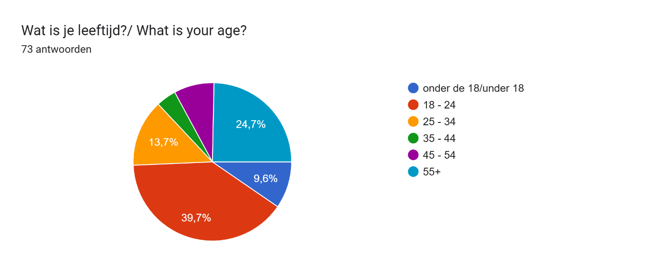

Appendix B

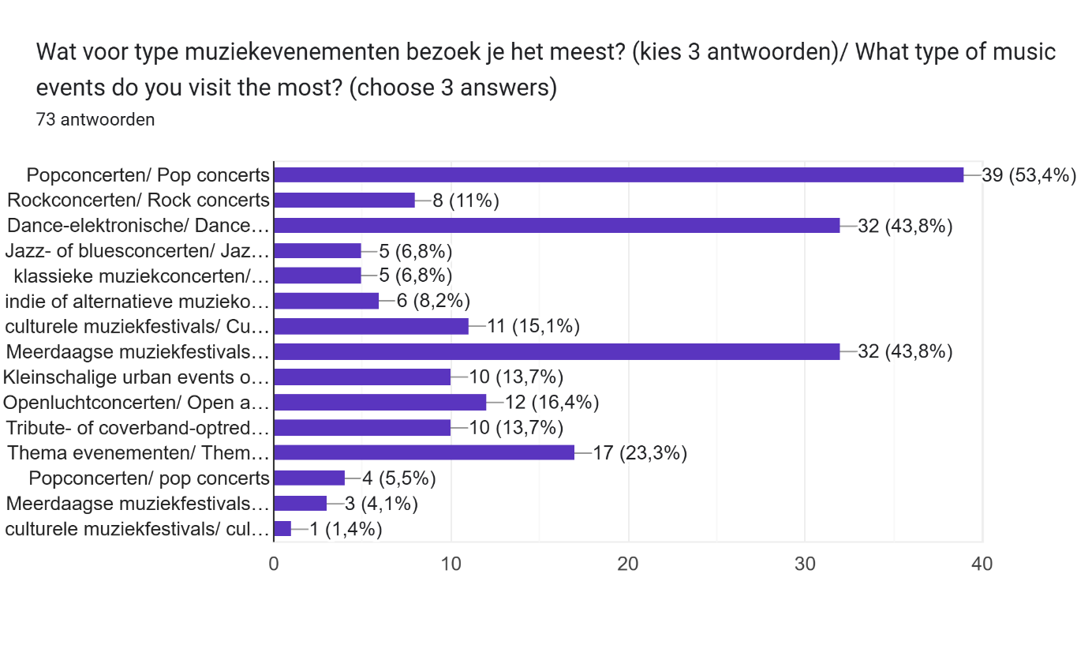

Appendix C

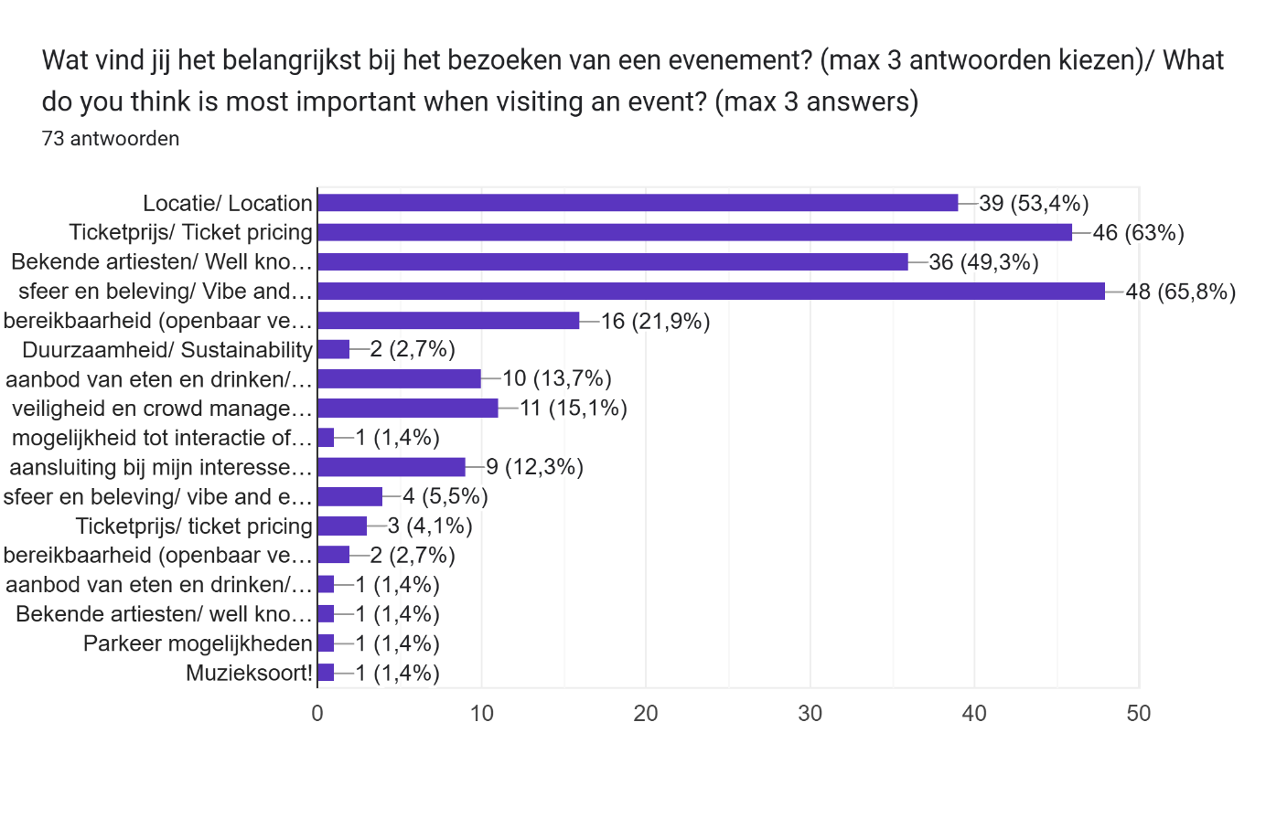

Appendix D

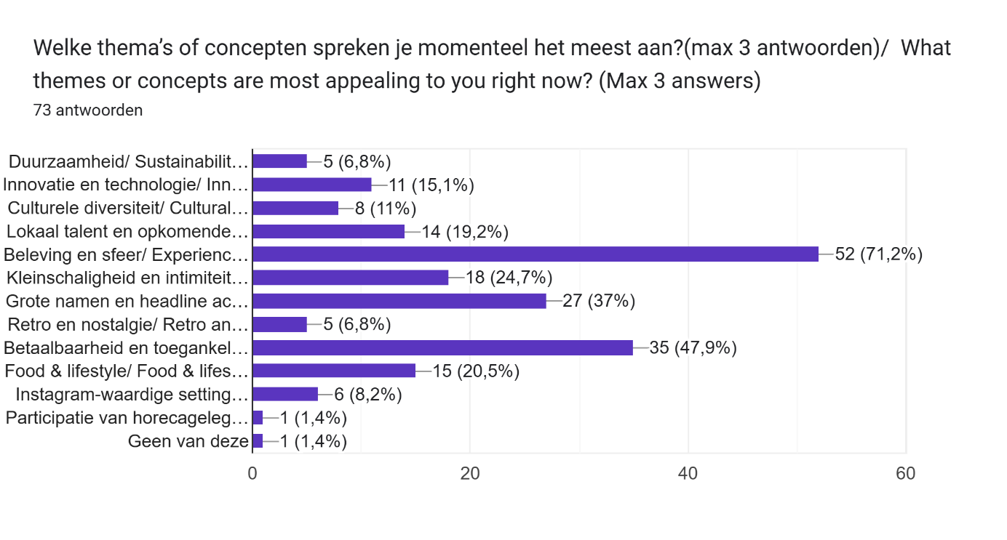

Appendix E

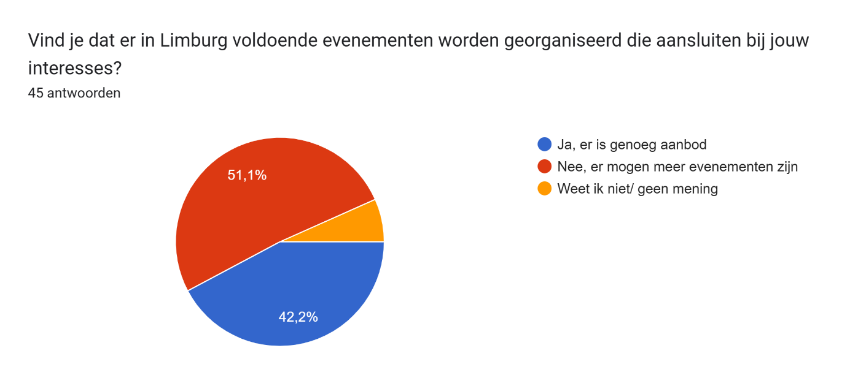

Appendix F

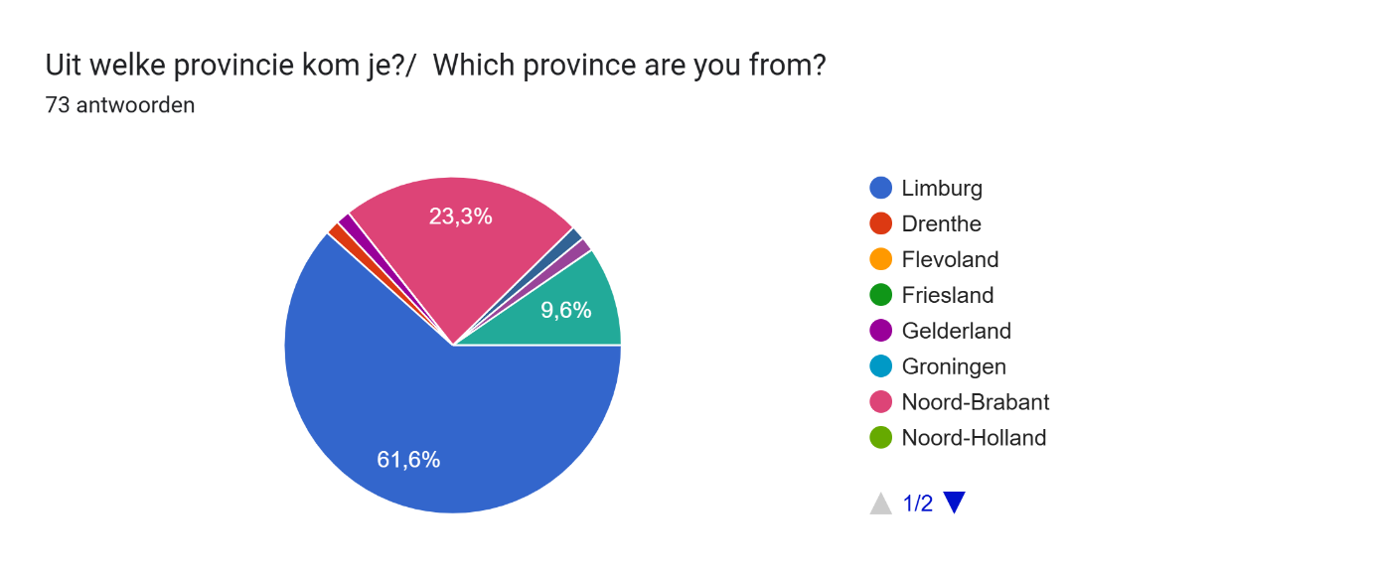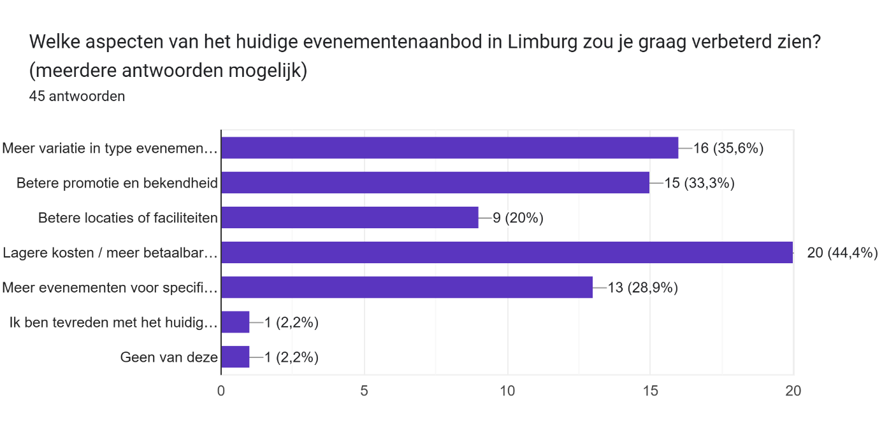

Appendix G

Appendix H

Date of Interaction: May 1, 2025  
Tool Used: ChatGPT (Mar 14 version) by OpenAI  
Accessed at: <https://chat.openai.com/chat>

Prompt:

Create 6 survey questions that find out event preferences of people, include age, trends, what type of music events and around 3 questions for a subsection that will focus on Limburg specifically and what respondents miss in the province event-wise.

ChatGPT Response:  
Below are the survey questions generated:

General Event Preference Questions

1. Wat is je leeftijd?  
   *What is your age?*
2. Wat voor type muziekevenementen bezoek je het meest? (kies 3 antwoorden)  
   *What type of music events do you visit the most? (choose 3 answers)*
3. Wat vind jij het belangrijkst bij het bezoeken van een evenement? (max 3 antwoorden kiezen)  
   *What do you think is most important when visiting an event? (max 3 answers)*
4. Welke thema’s of concepten spreken je momenteel het meest aan? (max 3 antwoorden)  
   *What themes or concepts are most appealing to you right now? (max 3 answers)*
5. Welke elementen maken een evenement voor jou memorabel? (max 3 antwoorden)  
   *What elements make an event memorable for you? (max 3 answers)*

Limburg-Specific Questions

1. Uit welke provincie kom je?  
   *Which province are you from?*
2. Vind je dat er in Limburg voldoende evenementen worden georganiseerd die aansluiten bij jouw interesses?  
   *Do you feel that enough events are organized in Limburg that match your interests?*
3. Welke aspecten van het huidige evenementenaanbod in Limburg zou je graag verbeterd zien? (meerdere antwoorden mogelijk)  
   *Which aspects of the current event offerings in Limburg would you like to see improved? (multiple answers possible)*
4. Welke evenementen of activiteiten mis jij in Limburg, waar je graag meer van zou willen zien?  
   *Which events or activities do you miss in Limburg and would like to see more of?*

Appendix I

Link to the survey

<https://forms.gle/RR9h45EQTFGrjdU19>