Research paper - Drug use in events
Nina Vigliaroni
June, 2025

Abstract
This research investigates the motivations behind drug use among event visitors in the Netherlands and identifies the most used substances in these settings. A mixed-methods approach was used by combining desk research, an online survey, and two in-depth interviews with frequent event-goers. Thematic analysis was used to identify recurring answers across qualitative and quantitative data.
Findings show that drug use is primarily motivated by the desire to enhance the event experience, increase energy levels, and reduce inhibitions in social settings. Commonly cited substances include ecstasy (XTC), MDMA, and cocaine, with many participants reporting polydrug use depending on the setting and group dynamics. Although users understand the risks and health hazard of using drugs like overdose, dehydration, and fatalities They mostly feel like these risks could be controlled, particularly in social settings with people that they trust. Common safety measures included controlling dosage, drinking plenty of water, and staying with friends.
The survey shows that drug use in events is very normalised in the Dutch culture with a majority of the users considering it be a part of the event experience. The factors that have an effect on drug use in event setting are better understood as a result of this research.

Introduction
In the last years, drug use at music events has become more common and normalised in the scene. What once was risky is now seen as part of the experience by many event visitors. Drugs like MDMA, Cocaine, ketamine, and cannabis are frequently used at festivals and raves. These are not only used to enhance the music and atmosphere but also to feel more connected to others or escape from daily life or stress. While this is normal to some, it comes with serious and risky consequences, especially because it can lead to affecting your own safety as well as others, lead to medical emergencies, or even result in fatalities.
Drug use at music events is examined in this research report. Finding out which substances are most commonly used, why people choose to use them, and how they perceive the hazards involved are the main objectives of the study. As someone who intends to work in the events sector, I also want to learn more about this problem so that I can contribute to the creation of safer environments for future event goers.
I will survey thirty music event attendees (Appendix A) and speak with three people to gain a deeper understanding of the issue of drug use at events (Appendix B). In addition, I'll examine research and publications that address drug use during events.
All of this will help answer the main research question:
What is the motivation of event visitors to use drugs and what types of drugs are most common in these settings?

Literature Review
Risk increases when different drugs are combined. not just because of unpredictable effects but also due to the added strain this puts on the body. According to Unity (n.d.), “every drug has its own risks, and combinations can lead to unexpected and intensified effects.” MDMA combined with antidepressants is very dangerous while SSRIs may dull the high of MDMA, older types like MAO can triggering a high blood pressure or even cause serotonin syndrome.
Even medication like asthma inhalers or hay fever pills can become a risk when paired with drugs. This can have effects like a higher heart rate or blood pressure. Another issue is timing, taking one substance while another is still active. Unity advices to test drugs, inform people of what you’ve taken and to be aware of risks they state “Mixing is never without risk.” (Unity. n.d)
(Unity, N.d., as cited in Vigliaroni, 2025)

According to the Alcohol and Drug Foundation (2025), using drugs at festivals and similar events comes with serious risks, making harm reduction efforts essential. Substances like ecstasy and MDMA are often found at these gatherings, and they can cause issues such as overheating, dehydration, a fast heartbeat, high blood pressure, anxiety, hallucinations, and unpredictable behavior. These effects can be made worse by heat, lots of physical movement, and other environmental factors. In some cases, people may drink too much water while using these drugs, which can be life-threatening.
Alcohol adds another layer of danger, as it can hide the effects of other substances, making it easier to accidentally take too much. Another concern is the unknown strength or purity of the drugs being used, which increases the chance of overdose and other health problems.
The environment of the event itself can also play a role in how substances affect people. Things like poor air circulation, dirty spaces, unhelpful or rude staff, and a lack of quiet places to rest can push people already under the influence toward aggressive or antisocial behavior.
(The Alcohol and Drug Foundation, 2025, as cited in Vigliaroni, 2025)

De Clerck et al. (2023), highlight that how common drug use is varies on the setting. The most common used drugs at festivals, outdoor parties and raves were MDMA, ecstasy, synthetic hallucinogens, ketamine, amphetamines, and poppers (alkyl nitrites). In nightclubs substances were similar but synthetic hallucinogens were used less. Cocaine use was higher here than at festivals or raves. The study found that cannabis was most used aside from alcohol. De Clerck et al. (2023) state that ‘’individuals high in excitement-seeking tendencies were more likely to engage in substance use and other risky behaviors.’’
Motivations for drug use were musical enjoyment, dancing, exploration, and excitement as key reasons. Cocaine and amphetamine users emphasized music, while ecstasy/MDMA users highlighted music and dance. These motives align with findings linking MDMA use to euphoria, sociability, self-insight, and a sense of sexiness. (De Clerck et al., 2023)
(De Clerck et al., 2023, as cited in Vigliaroni, 2025)

Mustafa (2022) explores the reason behind people using drugs at music festivals, mentioning the unique environment these events have. Professor Fiona Measham is a criminologist at the at the University of Liverpool and director of The Loop an organisation checking drugs at festivals. She states that festivals offer escapism and a break from daily routines and making them feel free. This feeling in combination with immersive settings creates an environment promotive to trying substances. Research from this organisation shows that one in six festival goers only use drugs recreational. This suggests that the festival setting plays a role in the decision to experiment. (Mustafa, 2022)
(Mustafa 2022, as cited in Vigliaroni, 2025)

Trevino (2022) researches what the most popular drugs are at music festivals. A U.S. Study with 976 participants by drugabuse.com found that 53% of live music event attendees use drugs or alcohol. With 93% consuming alcohol, 40% reported using marijuana, while 8% used hallucinogens or MDMA. The most used substances at festivals are alcohol, MDMA, ketamine, LSD, weed and psilocybin mushrooms. It is highlighted that due to the carefree atmosphere people see drugs as part of the experience. People view drug use as an enhancement of music and the experience however it comes with risks like bad trips and overdoses. (Trevino, 2022) mentions that music genres have different levels of substance use. Where EDM, heavy metal and alternative music events had the highest percentage with 67.5%, 52.2%, and 60.6% of attendees who drank alcohol or used drugs. In comparison, classical and rock music events had the lowest, with 39.8% and 39.6%.
(Trevino, 2022, as cited in Vigliaroni 2025)

Heshmat (2017) identifies seven reasons why people use drugs and emphasises the nature of addiction and its underlying causes. People use drugs to feel good and experience euphoria, this pursuit of positive sensations is a primary motivator for initial drug experimentation. Often drugs are used to reduce stress, anxiety, depression or trauma this is drug use to feel better, this approach aims to reduce negative emotions and psychological distress. Some people use drugs to do better To enhance physical performance, believing that drugs can improve focus, endurance, or academic and athletic abilities. Curiosity and social influence is another reason The desire to experiment, coupled with peer pressure and the influence of social environments often leads to drug use. Genetic predispositions and neurobiological factors can increase a persons susceptibility to addiction, they are likely to engage in and continue drug use this is called biological vulnerability. Exposure to environments with drug use can lead to drug use. The last reason is the developmental stage, adolescents and young adults are vulnerable to drug use because of ongoing brain development.
(Heshmat, 2027, as cited in Vigliaroni, 2025)

The FHE Health (n.d.) article examines the prevalence of drug use at music festivals and the types of substances used and associated risks. A CDC survey from 2018 found that 73,4% of music festival attendees used substances in the last year. Cannabis was the most used drug with (63,9%), ecstasy second (59,8%) and third was cocaine with (34,1%). Other substances encountered are alcohol, LSD, opioids, Adderall and psilocybin mushrooms. A Danish study added to these results with mentioning that 92,8% of festival attendees used cannabis in the past year, 66,7% used MDMA and 51,2% had used cocaine. Similarly, an Australian survey mentioned that majority of festival attendees aged 18–30 had a history of drug use. 86.5% of these participants support the implementation of free drug-checking services at festivals to mitigate harm.
(The FHE health, n.d., as cited in Vigliaroni, 2025)

Hill (2022) explores the prevalence and risks of drug use at music festivals and emphasises the importance of awareness and harm reduction. festival attendees engage in drug use with 75.5% consuming alcohol, 38.8% using marijuana, 13% taking MDMA/ecstasy, 8.5% using mushrooms, and 8% using LSD. Of these people 90% was using more than one substance.
Motivations to use was enhancing sensory experiences, easing social interactions in crowded environments was another reason. Combining drugs has risks as this can mask the effects of each drug. This leads to using more than intended and increasing risk of overdose while dancing, heat and dehydration can lead to health issues. MDMA can containe harmful adulterants like n-ethylpentylone, leading to dangerous reactions.’’’ Such contamination underscores the importance of drug-checking services at festivals, which can help attendees verify the contents of substances and make informed decisions.’’ (Hill, 2022)

(Hill, 2022, as cited in Vigliaroni, 2025)

Methodology
To explore the drug use at music events, I have used a combination of surveys, interviews, and desk research. The set goal was to get honest, personal insights from people who attend events both who use drugs and who don’t, as well as input from venues that host them.
The main part of the research was an online survey. I shared it through my personal social media, and friends helped spread it further by passing it on to their own networks. Most participants either attend events regularly or are part of the event community. Many have experience with drug use at events, but the survey also reached people who don’t use drugs, which allowed me to compare motivations, opinions, and experiences between both groups. In total I received 65 responses which is more than double than my original goal.
The survey included a mix of multiple-choice and open-ended questions. It covered topics such as what kinds of substances people have used (if any), their reasons for using or not using them, how they experienced the effects, and how they view the risks. It also asked how safe they felt at events and whether they noticed any efforts from organizers to manage drug use or support harm reduction.
In addition to the survey, I planned interviews to get more detailed, personal stories. I am interviewing two people between the ages of 18 and 30 who attend events regularly and have used drugs. I also would like to speak with one person who either doesn’t use drugs or is a parent with a child who goes to events. These conversations will help me understand different perspectives from both inside and outside the scene.
Finally, I’m also doing desk research to support the information I get from people. I’m using government data, news articles, and academic research to better understand the bigger picture especially around trends, risks, and existing harm-reduction strategies.
This research began on February 22nd and will continue until early June, with the aim of finishing everything before June 3rd.

Findings
This survey was answered by 65 participants
*cannabis was not taken into consideration as a drug because of such high use rates*
The people who filled in the survey ranged from ages 18 up to 60+. The top 3 age groups are 24,6% of 20 years old, 20% is 20 years old and 8% is 21 years old (Appendix C) 44 out of 65 people have used drugs (Appendix D). This is almost 2 out of 3 people. The most used substances are XTC, MDMA (molly), cocaine and speed (Appendix E) Half of the people used or use XTC, 31,8% MDMA (molly), 5 out of 65 people have used or use cocaine and 3 use or have used speed. Ketamine was not chosen by anyone. The top 3 reasons drug usage is to enhance the experience (45,5%), increased energy level (27,3%) and it being a cheaper option (11,4%). (Appendix F)
52,3% of users researches what they use in the sense of dosage, purity etc. when being asked how they ensure staying safe while using answered varied from timing, small doses at a time, not drinking too much, taking breaks to get fresh air, staying with friends and 2 out of 44 people answered they get their drugs tested to stay safe. When being asked if someone ever feels regret or any negative consequences after using 15 people said yes (Appendix G). These varied from feeling stupid for using, sadness/being emotional to tiredness. When being asked if they would consider alternative ways to enhance the event experience 10 out of 44 people mentioned drinking, 8 people mentioned just enjoying the event without anything and the other 26 said they would keep using drugs and don’t want an alternative.
When being asked if they see themselves using in the future 15 out of 44 people mentioned not wanting to use anymore, 9 people mentioned already using less or not seeing themselves using in the future, the remaining 20 mentioned they will keep using. When being asked opinions on drug use people mentioned drug use being scary and too normalised, that it should be able to happen, it is part of an event these days. One person mentioned ‘’ it's a pity that drug testing at festivals has stopped and there is a kind of false sense of security due to the 'zero tolerance policy'. Everyone knows that drugs are being used, but visitors are hesitant to raise alarms when things go wrong.’’
Health and safety is the highest chosen reason to not use drugs with 12 out of 21 people. Unpredictable experience is second with 6 out of 21 people. One other person mentioned “being afraid of a bad trip’’ (Appendix H) When asking the non users about their opinion on drug use at events the following was mentioned. Most people don’t mind it however do mention that it should not effect other visitors or attendees. If the drugs make people hallucinate or aggressive they feel like it shouldn’t be used. Other people mentioned finding it very unnecessary and unsafe. When being asked if they have ever considered using drugs 5 out of 21 people said yes. 90,5% of non users mentions feeling more comfortable attending an event where drug use is strictly enforced/prohibited (Appendix I). When being asked if event organizers should take a stronger stance on drug use 10 out of 21 people says yes the other 10 mentioned it not really having effect and that they should focus more on education and safe use instead of not allowing it. 1 person is unsure and has no opinion.
*When being asked if they would mind their (future) kids using 5 people answered they would mind, the other 36 don’t enjoy it but mention they would rather have them using safely and being responsible and wouldn’t necessarily really mind.
*this question was added later for users and non users, so received less answers*

Findings Interview
(Appendix B)
Dutch event attendees, Anna who is a 22-year-old marketing student from Maastricht and Jeroen, a 21 year old construction worker from Eindhoven shared there experiences with drug use at events.
When being asked the reason for using drugs at events Anna mentioned feeling free and increased sociability, she mentioned drugs being a cheaper option than buying drinks as well. She likes how drugs don’t leave her with a hangover and how she cares less about what people think and how they perceive her. Fear of missing out (FOMO), played a big role in her decision making, sometimes ending up with her taking drugs despite having intentions to stay sober. Jeroen similarly described enhanced sensory experiences and staying awake/energy as primary reasons for use, especially when attending multi-day festivals. Jeroen also emphasized social bonding at afterparties as a motivator
Anna mentioned using ecstasy and 3MMCusually combined and that her friends usually use MDMA and ketamine besides 3MMC and ecstasy. Jeroen tends to use MDMA and cocaine and uses ketamine during afterparties. Both mentioned drug use being normal in their social circles
Both interviewees acknowledged risks but mentioned to not really think about it too in depth. Anna did mention sometimes fearing overhydration and bad trips but mentioned these thoughts fade when she is at the events because of feeling secure with her friends. Jeroen had a bad experiences when taking too many drugs because of not feeling the effects soon enough and ended up in the first aid. This affected his behaviour by not attending events for 8 months but now also taking more caution. Both considered drug use normal within their communities and feel like it should be normalised.
It was notable that they found drug use normal, Anna mentioned that drugs are used openly at events and even encouraged. She did express concern about the romanticising of drug use on platforms like TikTok. Jeroen mentioned drugs should be normalised mentioning that his parents have very open attitudes about his and just want him to stay safe
These interviews highlight that drug use in the Netherlands is seen as a part of the experience and is shaped by many different reasons and influences. While people do understand risks they are seen as manageable by trusting on their environment.

Analysis
This part analyses the motivation for drug use among event attendees and the types most used. The findings are drawn from 65 survey responses, two in depth interviews and eight articles. Thematic analysis was used to identify reoccurring answers and connect the findings to the research question: What is the motivation of event visitors to use drugs and what types of drugs are most common in these settings?
A common theme found in the interviews and survey results is the reasoning for drug use with motivators like: to enhance the experience, increase energy and social interaction. Almost half (45,5%) of the survey respondents who use or used drugs (44 out of 65 people) chose ‘’enhancing the experience’’ as their main reason. This was followed by ‘’increased energy levels’’ (27,3%) and drugs being ‘’cheaper than alcohol’’ (11,4%) (Appendix F). The interviews add to these findings. Anna, a 22 year old student states that drugs make her feel ‘’very free” and less concerned with how others perceive her. Therefore emphasizing the emotional and social effect that drugs have. Jeroen, a 25 year old construction worker mentioned that drug use “makes everything just so much better” in event settings and that it helps him with staying awake at multi day festivals (Appendix B.2)
These motivations align with international findings like Heshmat (2017) who identifies sensation-seeking, stress relief, social influence, and escapism as common drivers of drug use. Mustafa (2022) highlights how attendees often use drugs to escape everyday routines and immerse themselves more fully in the event atmosphere. The most used drugs in this study were ecstasy(XTC), MDMA, cocaine and speed. Exactly half of the survey respondents use/used XTC, 31,8% used MDMA, 11,4% used cocaine and 6,8% used speed (Appendix E). Ketamine use was also mentioned in (Hill, 2022), however was not selected in the survey. In the interviews both interviewees mentioned ketamine use by friends or at after parties.
Combining drugs was mentioned many times. Anna mentioned combining ecstasy with 3MMC while Jeroen mentioned using MDMA and cocaine during events and switching to ketamine for afterparties. Hill (2022) found that at nearly 90% of festivals were drugs are being used attendees combine substances, increasing the risks of dangerous situations. De Clerck et al. (2023) found that at festival and rave setting MDMA, ecstasy, synthetic hallucinogens, ketamine, and amphetamines are commonly used. While at nightclubs cocaine was most used. Cannabis was the most used substance besides alcohol but was excluded from the survey due to its common use.
Despite people being aware of risks they find risks to be manageable especially when being with their trusted friends. Anna mentioned sometimes having concerns about bad trips and overhydration (water poisoning) but stated that “this fades when being at the event’’(Appendix B.1). Jeroen experienced a negative experience when he used too much and ended up in the first aid. This had him take a 8 month break however he resumed with more cautions stating that “situations like those can always happen,” (Appendix B.2).

Survey data was similar with 52,3% of drug using respondents researching dosage and purity only 2 out of 44 people mentioned testing their drugs as a precaution. Others mentioned taking small doses, not drinking too much and staying together with friends. When asked about post-use regret or negative consequences, 15 respondents mentioned tiredness, emotional instability, or simply “feeling stupid” (Appendix G).
These findings align with the harm reduction advice from Unity (n.d.) they warn for the dangers of mixing substances. emphasizing that “mixing is never without risk” and encourages users to test substances. The Alcohol and Drug Foundation (2025) highlights how festival conditions such as heat, crowding, and no ventilation can add to drug dangers, making education and on-site harm reduction essential.
A reoccurring theme was the normalisation of drugs in the event scene. Anna and Jeroen both mentioned that drug use should be normalised and is already normal and accepted in their friend groups. Anna mentioned that sometimes drug use is “hyped up” by others at events rather than discouraged, while Jeroen emphasized the generational acceptance, stating his parents are aware of his use and prioritize his safety (Appendix B).
De Clerck et al. (2023) found that people with high excitement-seeking tendencies are more likely to use drugs and view them as integral to the music and dance experience. Mustafa (2022) reported that one in six drug-using festival attendees do so only in festival settings, underscoring the influence of environment on perceived acceptability.
Survey responses add to this normalization. Many users expressed that drug use is “part of the experience” and felt it should be allowed and normalised. However, concerns were raised by non-users, particularly around safety and unpredictable behavior. 90.5% of non-users said they would feel more comfortable at an event where drug use was strictly prohibited (Appendix I), though the opinions were still very divided on whether event organizers should focus on bans or education.

Conclusion
This research was done to explore the reasons behind drug use in events and identify the most common substances. This was done by a survey with 65 answers, two interviews and articles. The research provides insight into the perceptions and context of recreational drug use within events. Other common reasons are
The findings show that motivations are diverse but mostly are to enhance the experience. increased energy, emotional freedom, social ease, and sensory enrichment. Factors such as affordability, peer influence, and fear of missing out (FOMO) were also mentioned as influences on the decisions to use drugs at events.
The most used drugs were XTC,MDMA, and cocaine, with some use of speed and 3-MMC. Combining drugs was showed to be very common especially with the interview participants who often combined multiple substances depending on the event. Despite knowing health risks many users mentioned feeling safe with their friends and relied on strategies such as dosage control, hydration to decrease risks.
Drug use was widely seen as normal within festival and nightlife settings. Participants mentioned open use, an accepting environment, and even encouragement. Both users and non-users acknowledged the risks, including physical effects and emotional effects, although these were considered manageable.
This study highlights how recreational drug use at events is formed not only by personal desires but also by environmental, cultural, and social factors. The findings contribute to a broader understanding of how drug use functions as part of the event experience.

References

De Clerck, E., Christiaens, J., De Moor, S., & Deflem, M. (2023). Substance use and attendance motives of electronic dance music (EDM) event attendees: A survey study. International Journal of Environmental Research and Public Health, 20(2023), 1821. https://doi.org/10.3390/ijerph20031821
FHE Health. (n.d.). The reality of drug presence at modern festivals. Retrieved May 21, 2025, from https://fherehab.com/learning/how-common-drugs-festivals
Heshmat, S. (2017, November 28). 7 common reasons why people use drugs. Psychology Today. Retrieved May 21, 2025, from https://www.psychologytoday.com/us/blog/science-choice/201711/7-common- reasons-why-people-use-drugs
Hill, E. (2022, June 7). Drug use at music festivals: Everything you need to know. Bicycle Health. Retrieved May 21, 2025, from https://www.bicyclehealth.com/blog/drug-use-at-music- festivals
Mustafa, T. (2022, August 24). ‘It’s the freedom of being away from normal life’: Why people experiment with drugs at festivals. Metro. Retrieved on May 20, 2025 from https://metro.co.uk/2022/08/24/why-people-experiment-with-drugs-at-festivals- 17187522/
Trevino, S. (2022, July 26). What are the most popular drugs used at music festivals? More Than Rehab. Retrieved May 21, 2025, from https://morethanrehab.com/2022/07/26/what-are- the-most-popular-drugs-used-at-music-festivals/
Unity. (n.d.). Drugs combineren. Retrieved on March 14, 2025 from https://unity.nl/nl/drugs- gebruiken/party-gebruik/drugs- combineren/

Appendix
Appendix A: survey questions
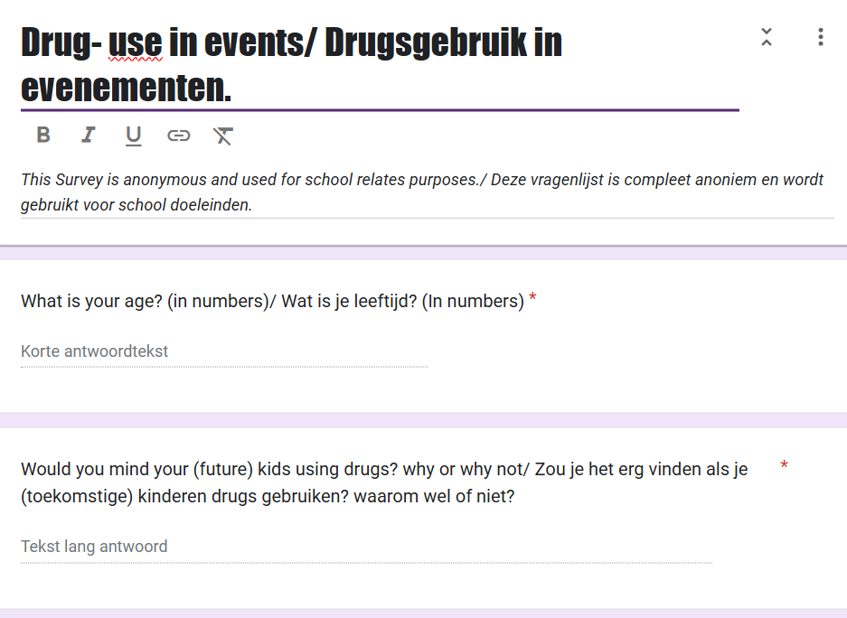
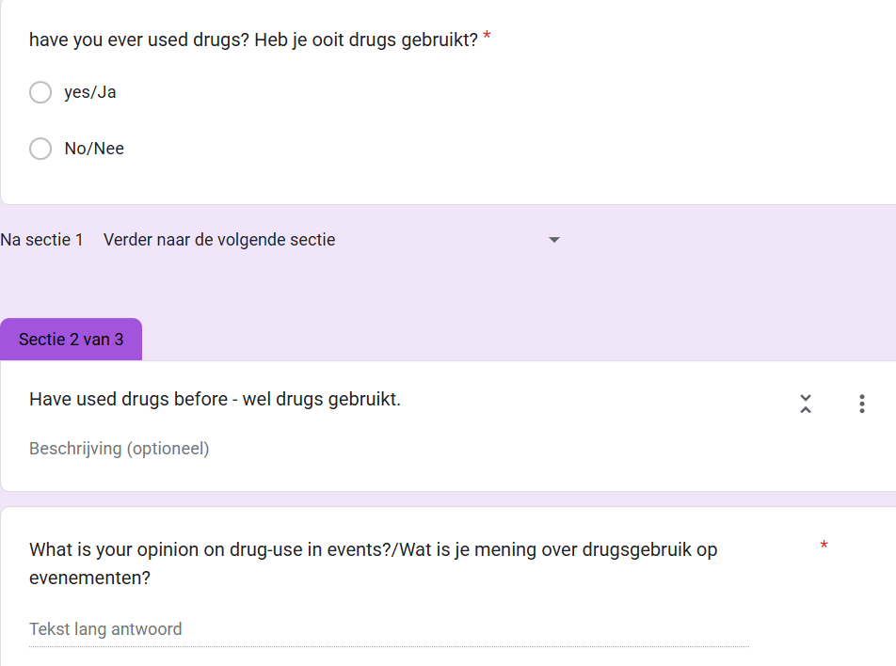
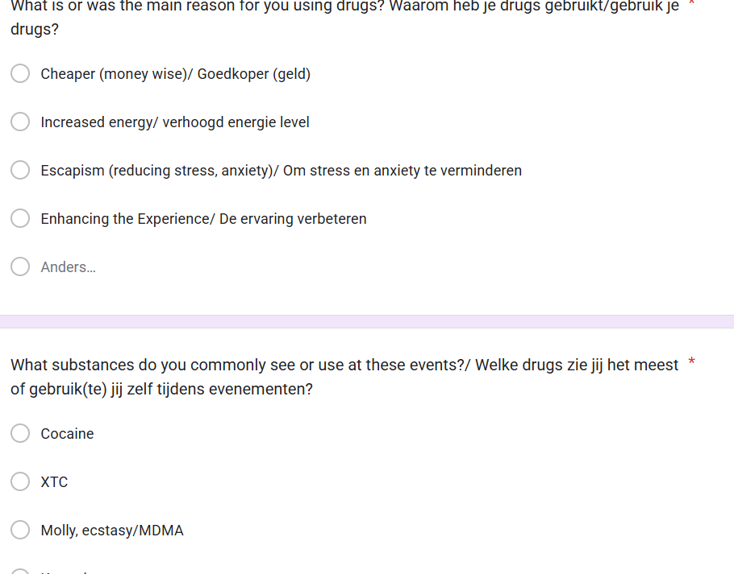
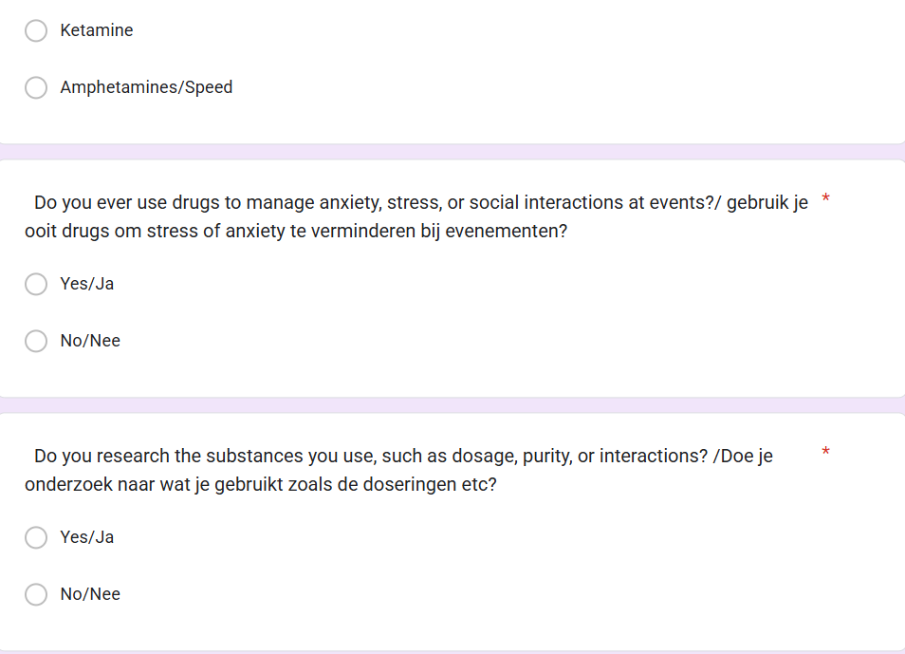
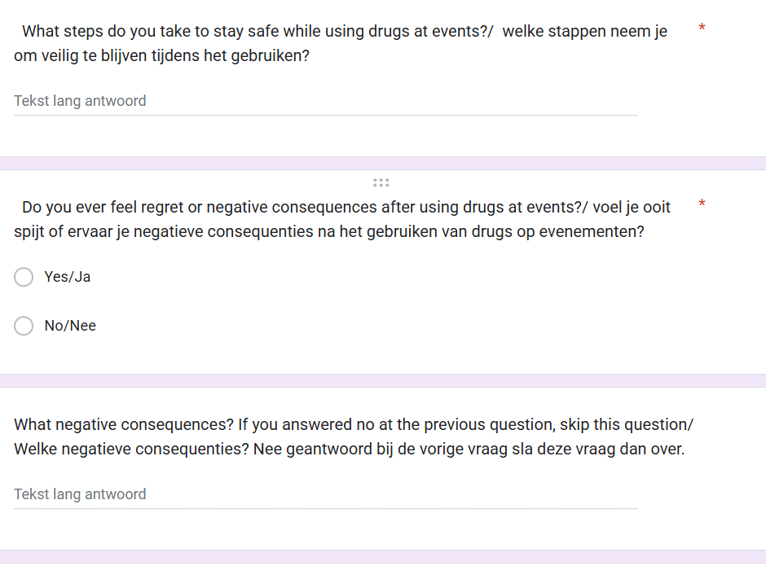

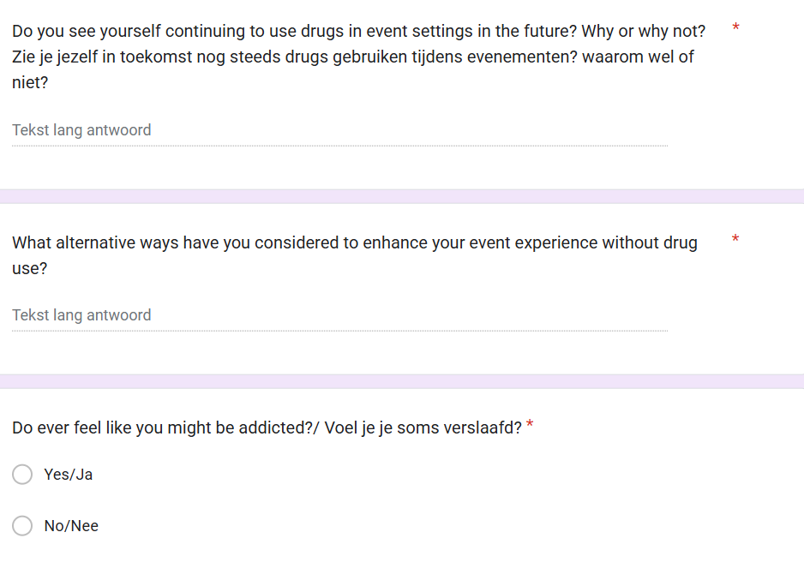
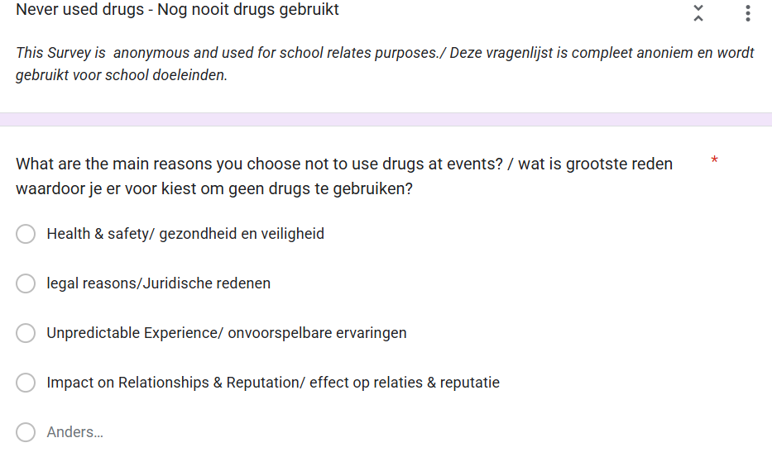
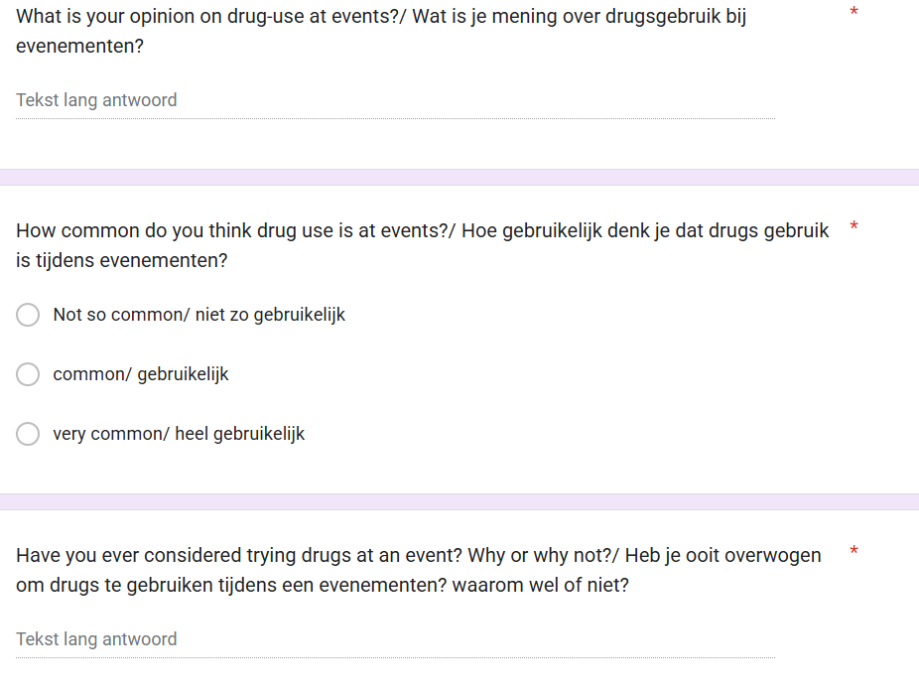
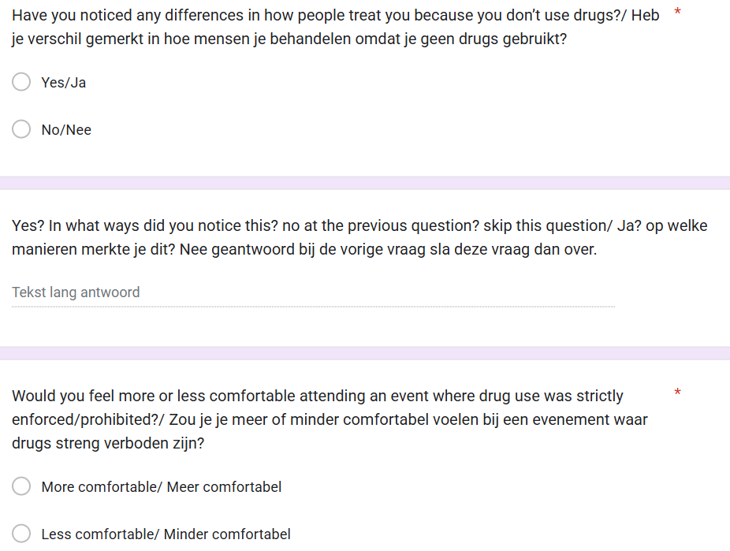
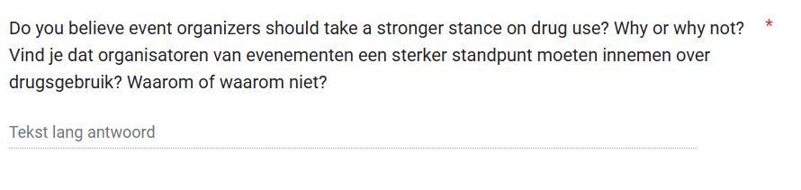

Appendix B.1 – interview Anna
Anna is a 22 year old marketing student in Maastricht who attends techno parties regularly
*For privacy reasons names have been changed*

Q:’’Can you tell me about your experiences with drug use at festivals, parties, or other events?’’
A: ‘’I usually use drugs when attending raves and I really enjoy it overall I have never had a bad experiences and I started using 2 years ago so thus far it has been all fun.’’
Q:’’ are you scared of having a bad trip since your experience have been positive up till now?’’
A: ‘’I do get a bit scared beforehand but that does fade after 30 minutes, I usually go with many friends so I do think that if it happens I will be in a safe situation but yeah it is something that I do think about but maybe not enough to really stress about it.’’
Q: How often do you or people around you use drugs in these settings?
A: ‘’Uhm almost every time time I personally go maybe 2 times a month sometimes less sometimes more it depends on the line up and my planning’’
Q:’’ Don’t you ever feel like maybe that is too much like 2 times a month or more?’’
A: ‘’Sometimes I feel like oh maybe I shouldn’t go but then friends are going, and I don’t want to miss out so then I do go and when I am there I don’t really give it a second thought’’
Q: ‘’So you are saying that FOMO plays a big part in you attending the events so often?’’
A: ‘’yes it definitely does!’’
Q: ‘’So have you considered attending and either just drinking or completely staying sober? That way you are not missing out but are using less drugs’’
A:’’I have, and I also went multiple times without drugs but then I get tired and usually my friends do have drugs with them, so I end up taking it anyways’’
Q:’’Do they then pressure you to take it, or do you ask them if you can have some?’’
A:’’ Usually they do offer not like pressuring but just asking, but it has been my own choice to take it no one pressured me or anything like that’’
Q: Which types of drugs do you see or use most commonly at the events you attend?
A: ‘’I usually take ecstasy and 3MMC, but my friends also use MDMA and sometimes ketamine besides those’’
Q: ‘’do you use the ecstasy and 3MMC at the same time?’’
A: ‘’Yes, most of the times I do’’
Q: ‘’what is the reason for you using drugs at these events?’’
A: ‘’It’s cheaper than drinking and doesn’t give me a hangover also it makes me feel like very free and I notice that I care less if that makes sense haha’’
Q: Do you think reasons for using differ depending on the event (e.g., club night vs. festival)? If so, how?
A: ‘’Yeah I think so at a nightclub I would use to stay awake and have more intense experiences but a festival I probably wouldn’t even use drugs to be honest’’
Q: ‘’How do you perceive the risks of using drugs at events? What are the biggest concerns, if any?’’
A: ‘’Uh I am scared that I drink too much water and sometimes of a bad trip but like mentioned I don’t really think about it too much.’’
Q: ‘’Do you feel that drug use is normalized in the event scenes you’re part of? ‘’
A:” Yes, almost everyone uses drugs and they do it in the public too and usually people start hyping them up instead of looking weird or something like that”
Q: ‘’How do you feel about that?’’
A:’’ Good actually I feel like it can be normalised at events because it is happening anyways so why fight
it.’’
Q: ‘’And how do you for example feel about pingtok which is where people kind of romanticise drug use on TikTok?’’
A:’’ I do feel like that is strange because everyone can see those things and I do think that it should stay offline and not be romanticised but rather normalised’’

Appendix B.2 – Interview Jeroen
Jeroen is a 25 year old from Eindhoven who works in construction and attends events in his free time
*For privacy reasons names have been changed*

Q: ‘’What events do you usually attend?’’
A: ‘’Mostly hardcore events and I really enjoy multiple day festivals as well I am really looking forward to intents right now’’
Q: ‘’Do you always use drugs and when attending a multiple day festival do you then also use drugs all days?’’
A:’’ Mostly yes, sometimes I am the driver so in that case I stay sober. That is also why I prefer the multiple days because no one has responsibilities to drive or anything. Yes in that case I use drugs all days’’
Q: ‘’Don’t you think that that is dangerous to use 2-3 days in a row’’
A: ‘’ It has never gone wrong yet so I don’t consider the dangers, but we look after each other very well and take rest when needed’’
Q: ‘’What drugs do you take?’’
A:’’ MDMA, cocaine and at the afterparty mostly ketamine.’’
Q: ‘’Can you tell me about your experiences with drug use at festivals, parties, or other events?’’
A:’’Mostly my experiences have been very good however nothing compares to the first time. There was one time where I went bad and don’t really remember too much but I do know that I was at the first aid. I just took a bit too much because I felt like I didn’t feel anything yet but after taking more it al kicked in at once so now I leave more time in between’’
Q:’’Have you considered stopping after that experience?’’
A:’’Not really I did not use for like 7 months when that happened and took a break because it did scare me but situations like those can always happen and 9/10 times it went well, and I had the most amazing experiences. But I am a bit more careful now.’’
Q:’’Why do you use drugs?’’
A:’’ I love how it makes me feel everything just is so much better and it helps to stay awake and have energy especially when it is a 3 day festival. It is also just so much fun to have afterparties with your friends and just the vaguest shit happens’’
Q: ‘’Do you feel that drug use is normalized in the event scenes you’re part of?’’
A:’’Yes for sure but I think that that is a good thing, when my parents were younger it was also quite normal. They also know that I use and don’t find it strange just want me to be safe and be responsible’’
Q:’’Have your motivations or drug choices changed over time? What influenced those changes?’’
A:’’ Yes, first it was because I wanted to experiment and it was cheaper than the drinks at the venues especially when sharing with friends and I used multiple different drugs now it is just about fun and the experiences and I stick to MDMA, cocaine and ketamine so I know the effects and how I react to it.’’

Appendix C: Age group survey answers
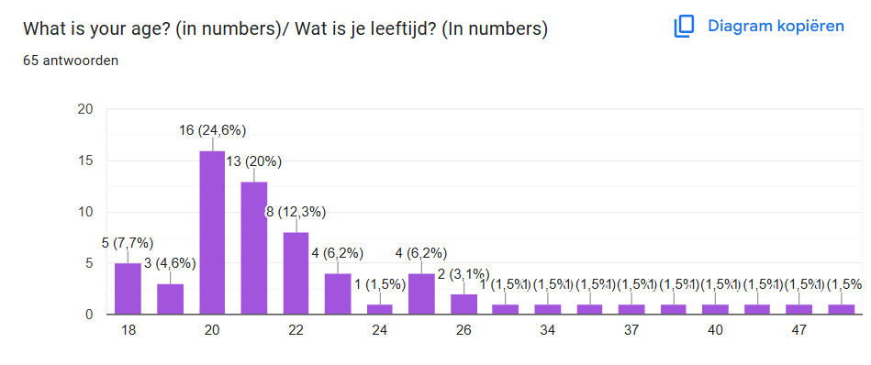
Appendix D: Drug use
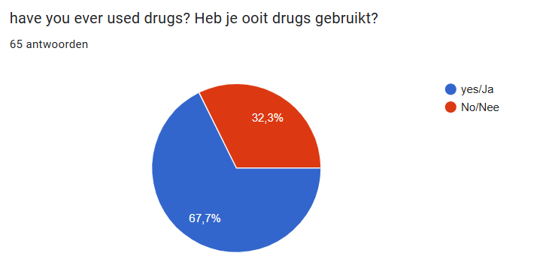

Appendix E: What substances are used
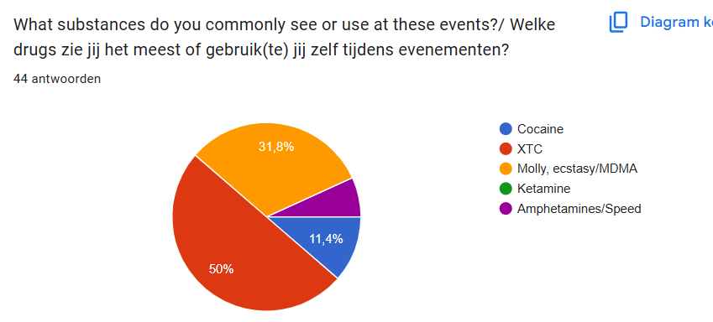

Appendix F: Reason for using
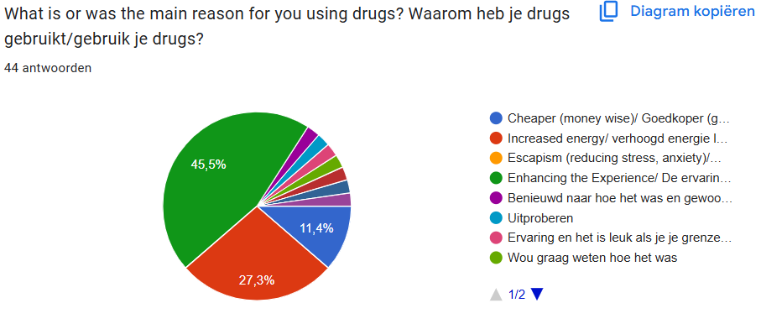
Appendix G: regrets after using
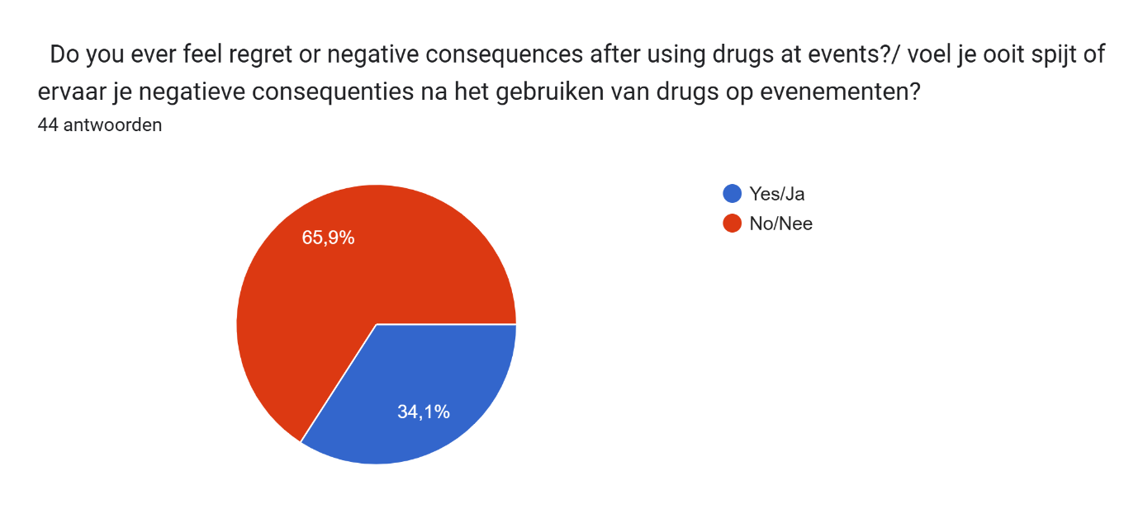
Appendix H: reason for not using
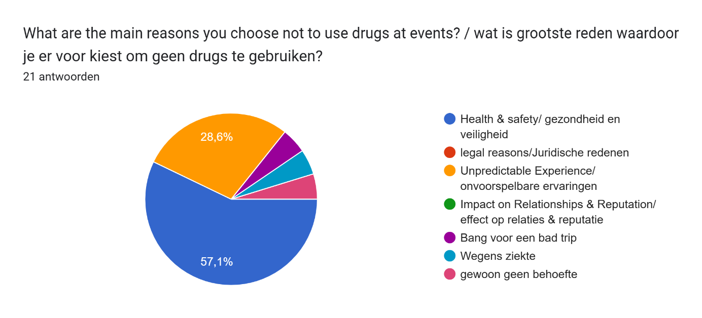
Appendix I: comfortable – non users
