Afbeelding met tekst, poster, grafische vormgeving, Vlieger

Door AI gegenereerde inhoud is mogelijk onjuist.

**Introduction**

‘’A fan or fanatic, sometimes also termed an aficionado or enthusiast, is a person who exhibits strong interest or admiration for something or somebody, such as a [celebrity](https://en.wikipedia.org/wiki/Celebrity).’’ (Wikipedia, N.D)

Solist Events organizes themed events based on popular artists and music genres like Taylor Swift, The Weeknd, EDM, Throwback nights, House, White Girl Music, and Guilty Pleasures. Right now most of these events take place in Rotterdam, Amsterdam, and Utrecht.

The goal of this research is to find out where Solist Events can grow and how to make the events even better, by understanding what the audience really wants. the focus will be on all types of events to see which ones connect best with fans mostly aged 16 to 25 and older.

One challenge is expanding to places like Limburg, where I’m from. Solist also has followers there, but it’s not a central location. Most big events happen in the Randstad area, which is hard to reach for people from Zuid Limburg. This could actually be a great chance to bring events closer to those fans who don’t have many options nearby.

This research will help figure out which event themes work best and give advice on how Solist can grow in new places while keeping current fans happy.

**Research Question & Objectives**

Main Research Question:  
What is the market potential for Solist Events artist-based and themed events in the Netherlands?

Sub-objectives:

* Determine the optimal ticket price range for different event types.
* Identify locations with the highest demand, including the potential for expanding into regions like Limburg.
* Discover which events perform best: artist-specific or themed-based.
* Understand what the audience feels is missing from current event offerings.
* Identify the most effective marketing channels to reach the target audience.

**Research Methods**

For the desk research, I will look artists and fandom. The survey will take place during the events themselves. I’ll use Google Forms and create a QR code so people can easily scan it and fill out the survey on their phones. The goal is to get at least 25 responses from attendees with different tastes. Since Solist Events prefers not to share the survey on their social media, the survey will only be promoted in person at events.

**Survey findings**

This survey has 41 respondents

34,1% has heard about Solist via Instagram, 31,7% via Tiktok, 26,8% word to mouth and 4,8% on both, TikTok, insta and via friends, 2,4% had never heard of it before. (Appendix A)

56,1% of visitors prefers a DJ or club night with specific genres or themes. 29,3% of visitors prefers a themed night such as throwback, 90’s, guilty pleasures etc and only 9,8% prefers nights dedicated to one artist. (Appendix B)

Looking at pricing of tickets 48,8% is willing to spend between €10 – 15 per ticket. 31,7% is willing to spend €15 – 20. Lastly €20-25 is a ticket price 19,5% would be willing to pay. (Appendix C)

Location of the event is the biggest influence/reason to attend an event (68,3%). The theme/artist is runner up with 58,5% and pricing the third with (39%). (Appendix D)

13 out of 41 people want an event to take place in Breda,8 in Rotterdam and 5 in Eindhoven. (Appendix E)

*\*this question was added later and therefore has less answers* (22 ANSWERS)*

31,8% is willing to spend 30-45 minutes of traveling to an event, 22,7% 60+ minutes and a shared 18,2% for 15 – 30 minutes and 45 – 60 minutes. Other mentions were “depends on how good the line up is’’ and ‘’I travel a lot so everything is fine”. (Appendix F)

A unique setting/location (63,4%) and interactive elements such as photobooths (61%) make an event more special. (Appendix G)

**Desk Research findings**

Boothby, Cooney and Clark (2016) explore how having experiences with other people effects how people experience events both positively as negatively. They found that shared experiences have the effect to enhance emotional intensity and make them more enjoyable. The psychological explanation for this is heightened attention. ’’When individuals are aware that someone else is going through the same event simultaneously, it intensifies their own emotional response.’’ This suggest that even just being in the presence of others is enough to create these feelings. Showing that social context can greatly impact individual perception and enjoyment

(Boothby, Cooney, & Clark, 2016).

Barone (2021) researches the psychology behind fandoms with a focus on why people have strong attachments to musicians or other public figures. The research identifies drivers ‘’parasocial relationships, where fans feel deeply connected to celebrities despite no real-life interaction, and social identity theory, where being part of a fanbase strengthens personal identity and community belonging.’’ The research highlights that finds find emotional support, identity and guidance from their favourite celebs. This can drive behaviour, lifestyle choices and creates group dynamic.

This makes fandoms a great marketing force. The research implements that fan-driven events thrive because of this closeness, sense of belonging and shared experiences.

(Barone, 2021).

Rajan and Kumar (2024) explores emotional and psychological aspects of fangirls

It mentions that fans often form intense emotional bonds with fictional characters, celebrities, or musicians. This is because of escapism, indetity information, emotions and desire of belonging. Fangirl behaviour is often misunderstood but it can actually be seen as a form of self-expression and identity-building. The emotional investment helps with adolescence, develops empathy and to feel part of a supportive community. Female fandom is often dismissed but can be seen as similar to male fan behavior in sports.

(Rajan & Kumar, 2024).

Bryant (2022) In this analysis it is argumented that fangirls are shapimg the internet. As fangirls often lay the foundation for online communities, trends, and digital fan engagement before mainstream media. The article mentions how young adults in fan communities make great use of Tumblr, Twitter, Tiktok and more to create memes and build connections, digital fan cultures are community-driven.

(Bryant, 2022)

Wiest (2017) explores how fan communities mostly young people are providing mental health benefits. ‘’Drawing on insights from psychologists, the article emphasizes that fandoms offer a sense of belonging, emotional expression, and social connection. For many teens and young adults, participating in a fandom becomes a vital outlet for creativity, identity exploration, and coping with stress or isolation.’’ Wiest (2017). Fan engagement helps with confidence, self-worth and connections. A fandom is seen as a safe space

(Wiest, 2017)

**Experiences with traveling from Zuid-Limburg to an event**

‘’I don’t like traveling with public transport. Most of the times it takes you longer to get to your location and you are stuck to specific times. Events and festivals are usually till quite late and there are no trains or busses going anymore”

– Celine (Kerkrade, Zuid-Limburg)

‘’Because I find it really hard to get back home to Limburg with public transport I sometimes cancel events or decide not to go even though I really wanted to. If I do go I usually have to leave early to get the last train back to Limburg, that makes me quite sad because I miss things.’’

– Tio (Heerlerheide, Zuid-Limburg)

‘’Going to events in Utrecht, Nijmegen or Amsterdam is always a big drama. Public transport from Heerlen is never organised well and we always have to take multiple trains. It is also quite tiring to have to travel for these long hours.’’

– Megan (Kerkrade, Zuid-Limburg)

‘’I almost always go to Sportpaleis in Antwerpen. This venue is easily reachable by car and my concerts are always amazing. It is only chaotic at the entrances. Public transport is okay for me but if I take it I have to leave earlier since its still 2+ hours to get back usually.’’

- Laura (Brunssum, Zuid-Limburg)

**Insights survey event preferences – specific questions on Limburg**

51,1% thinks there can be more events being offered in Limburg, 42,2% believes there is already enough and 6,7% is unsure or does not have an opinion. (Appendix E)

When being asked what aspects of the event offerings people would like to see being improved answers chosen were lower costs (44,4%), more variation in the events (35,6%) and better promotion of the events (33,3%) and more events for specific target groups like kids or adults (28,9%). (Appendix F)

When being asked what events or activities people miss in Limburg answers were: House events, events in the city centre square, EDM events, weekend events, open air events, family oriented events, uptempo events, kids events, events for people 50 and up, things with movies/parties like in hallmark movies big city/community parties, club nights with themes (more club nights in general) and more jazz and blues events.

**Conclusion**

The desk research and survey results provide insights for the market potential of Solist events artist-based and themed events in the Netherlands. Articles and studies show emphasis of the emotional and psychological value of shared experiences (Boothby, Cooney, & Clark, 2016). These findings highlight the emotional effect and community aspect central to themed and artist-centric events. Fandriven engagement, especially online, continues to shape digital culture and can be used for marketing purposes (Bryant, 2022).

Survey findings identified a clear audience preference for themed events (56.1%) over single-artist nights (9.8%), with pricing indicating a sweet spot of €10–15 for ticketing. Location remains the most decisive factor for attendance (68.3%), suggesting that logistical accessibility especially in underserved areas like Zuid-Limburg is wanted. The data from Limburg respondents highlights travel barriers that directly affect event attendance and satisfaction, pointing toward a strong opportunity for regional expansion.

Limburg audiences value unique, interactive settings and desire more variety, lower costs, and better promotion indicating a demand for curated, immersive, and well-communicated events. Social media platforms like Instagram and TikTok prove to be highly effective marketing channels.

Solist Events has strong market potential, particularly by focusing on genre-based themed nights, pricing tickets between €10–15, targeting central and underserved regions like Limburg, and leveraging fan culture dynamics through engaging, community-focused marketing strategies.

**Recommendations**

Based on the findings from desk research, survey results, and regional feedback, the following strategic recommendations are proposed for Solist Events:

Themed Nights over Artist-Specific Events

With 56.1% of respondents preferring genre- or theme-based events (e.g., 90s throwbacks, guilty pleasures), this format should be the most implemented event type.

Examples could be: Halloween party, festival or concert pre.after parties. Based on research photo booth, decoration and are important for visitors.

Marketing Strategies

Instagram and TikTok are the channels solists gets seen the most on. Almost 65% of visitors discovered solist via these platforms.

Content should be short-form for best attention span, Behind the scenes could be interesting, a follower collab for an event – Tiktok idea 🡪 Fans decide the event etc.

Instagram Reels, TikTok trends, and countdowns to generate pre-event hype.

Target Cities or Regions

Breda, Rotterdam and Eindhoven were most demanded in the survey and are locations that are well accessible and central from multiple locations.

*Expansion Focus:*

Zuid-Limburg (Heerlen, Maastricht or Sittard) travel barriers cause these residents to miss out on many events. Offer regional events or (very small) shuttle services/carpooling to increase access.

Consider Maastricht or Sittard as strategic Limburg locations due to infrastructure and centrality. Cavo in Maastricht would be a cool uniwue locations for a EDM/house event.

Pricing Strategies

Maintain accessible ticket pricing the most attractive ticket range is €10–15 (48.8% of respondents).

For events that offer more value and experience a €15–20 tier can be justified, but should offer added value (e.g., better venues, live elements, specific drinks/free entrance shot or photobooths).

**Reference list**

*Fan (person).* (n.d.). *Wikipedia*. Retrieved May 15, 2025, from <https://en.wikipedia.org/wiki/Fan_(person)>

Boothby, E. J., Cooney, G., & Clark, M. S. (2016). Shared experiences are amplified. *Emotion, 20*(2), 132–137. Retrieved May 15 <https://doi.org/10.1037/emo0000174>

Barone, T. (2021). The psychology of fandom: Why we get attached to musicians and athletes. *Academic Festival*, 6(1), Article 51. Sacred Heart University. Retrieved May 15, 2025 from <https://digitalcommons.sacredheart.edu/acadfest/2021/all/51>

Rajan, G., & Kumar, N. (2024, July 7). Investigating the psychology of fangirl culture and female attachment to fictional characters. *Psychologs*. Retrieved May 16, 2025, from [https://www.psychologs.com/investigating-the-psychology-of-fangirl-culture-and- female-attachment-to-fictional-characters/](https://www.psychologs.com/investigating-the-psychology-of-fangirl-culture-and-%09female-attachment-to-fictional-characters/)

Bryant, K. (2022, June 15). How fangirls created the internet as we know it. *Vanity Fair*. Retrieved May 16, 2025, from [https://www.vanityfair.com/style/2022/06/how-fangirls-created-the- internet-as-we-know-it-kaitlyn-tiffany](https://www.vanityfair.com/style/2022/06/how-fangirls-created-the-%09internet-as-we-know-it-kaitlyn-tiffany)

Radin, S. (2018, August 9). Psychologists say fandoms are amazing for your mental health. *Teen Vogue*. Retrieved May 16, 2025, from [https://www.teenvogue.com/story/psychologists- say-fandoms-are-amazing-for-your-mental-health](https://www.teenvogue.com/story/psychologists-%09say-fandoms-are-amazing-for-your-mental-health)

Wiest, B. (2017, July 20). Psychologists say fandoms are amazing for your mental health. *Teen Vogue*. Retrieved May 16, 2025, from [https://www.teenvogue.com/story/psychologists- say-fandoms-are-amazing-for-your-mental-health](https://www.teenvogue.com/story/psychologists-%09say-fandoms-are-amazing-for-your-mental-health)

**Appendix**

Appendix A

“How do you usually hear about events of Solist?’’

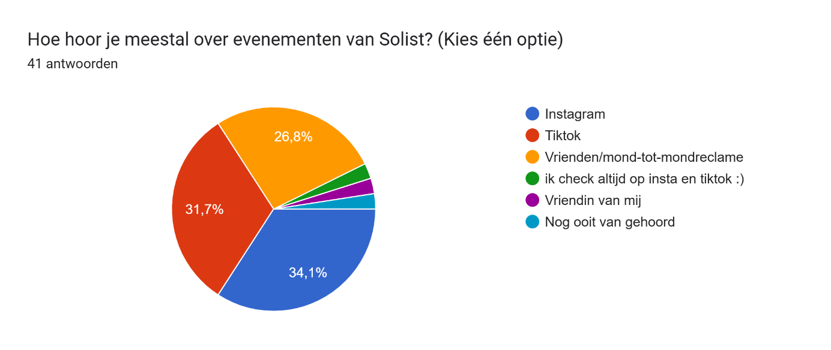

Appendix B

“What type of events speak to you the most?’’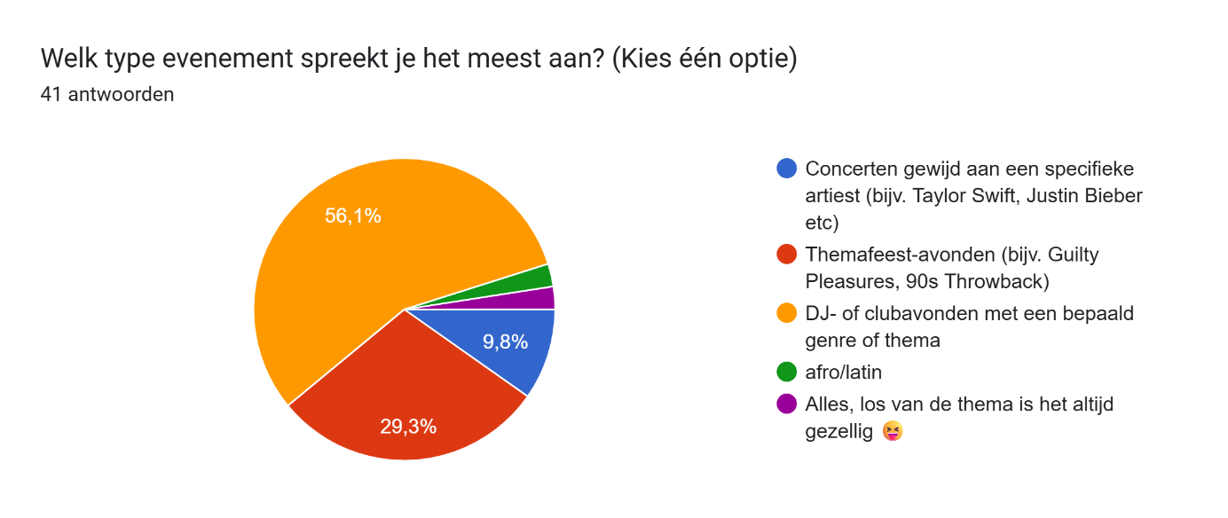

Appendix C

‘’How much are you willing to pay?’’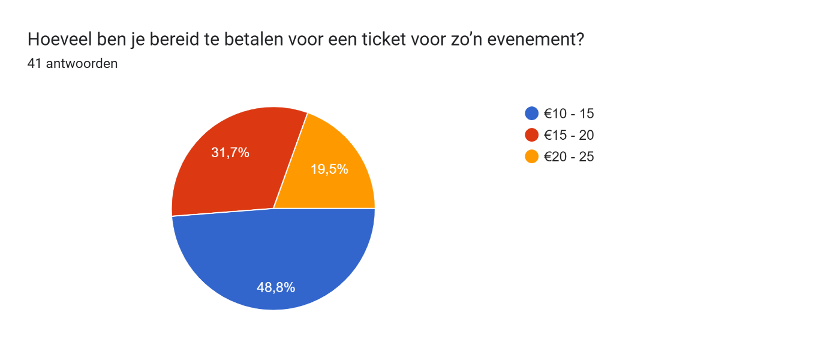

Appendix D

‘’What elements influence your choice to attend an event? (max 2 answers)’’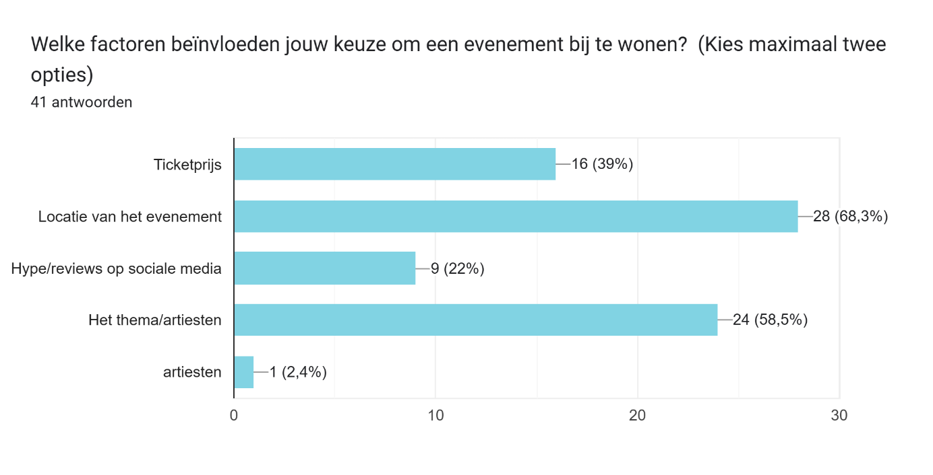

Appendix E

‘’In what city would you prefer a Solist event?’’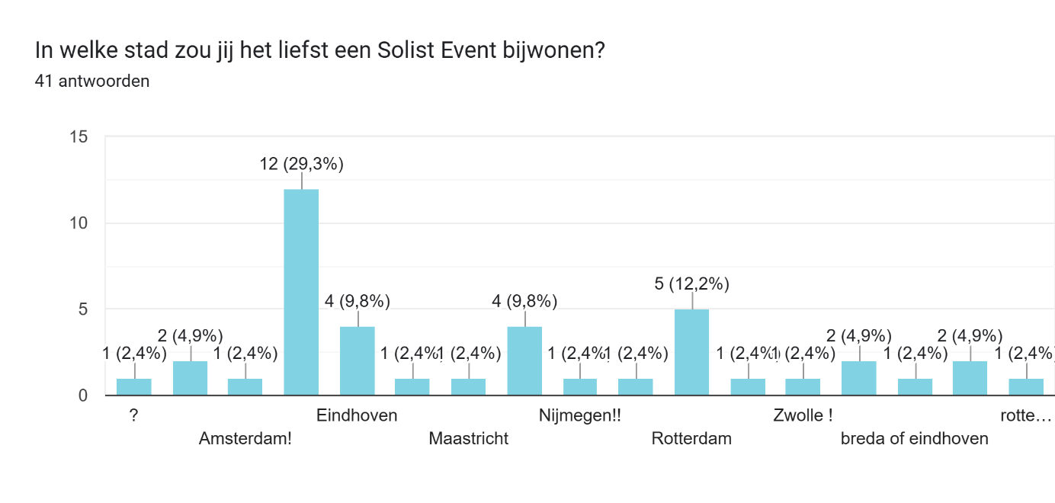

Appendix F

‘’How far are you willing to travel?’’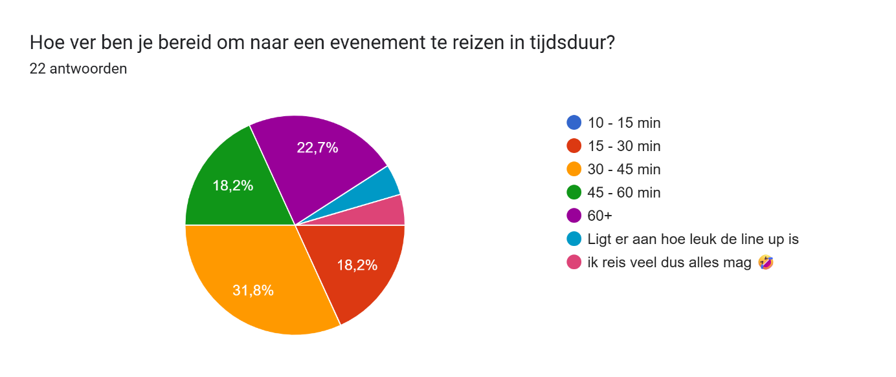

Appendix G

‘’What would make an event extra special for you? (choose 2 answers)’’